Lesson 3: Describing Quantitative Data: Shape, Center, & Spread
Preparation

Solutions
Please note that the steps show rounded numbers, but that the final answers to the problems are calculated without rounding.
Problem | Part | Solution
1 | Shape | c. Symmetric, bell-shaped, skewed right, and skewed left, uniform, unimodal, bimodal, or multimodal
1 | Center | a. Average, mean, median, mode
1 | Spread | b. Standard deviation, variance
2 | - | The standard deviation is a measure of the spread in a distribution. If the standard deviation is small then the data tend to be closer together. If the standard deviation is large, the data is usually more spread out.
3 | - | Answers will vary
4 | - | Sample variance is also a measure of spread in a data set. The sample variance is an estimator of the true population variance. The sample variance is just the sample standard deviation squared or $s^{2}$.
5 | Percentiles | A percentile is a number such that a specified percentage of the data are at or below this number, such as at the 50th percentile, this value is as large or larger than 50% of all the data.
5 | Quartiles | Quartiles are just three special percentiles, ${25}^{th}$, ${50}^{th}$, and ${75}^{th}$ percentiles divide the data into fourths.
5 | Five-number summary | The five number summary is comprised of the minimum, first quartile, median, third quartile, and maximum. It is just a good way to summarize the data into just five numbers.
5 | Boxplot | A boxplot is a graphical representation of the five-number summary.
6 | Company A | Mean: 21.276 Standard Deviation 37.679 n: 41
6 | Company B | Mean: 33.482 Standard Deviation 49.311 n: 25
6 | Company C | Mean: 41.122 Standard Deviation 79.177 n: 27
6 | Company D | Mean: 0.706 Standard Deviation 21.054 n: 49
6 | Company E | Mean: -1.084 Standard Deviation 21.297 n: 32
7 | - | 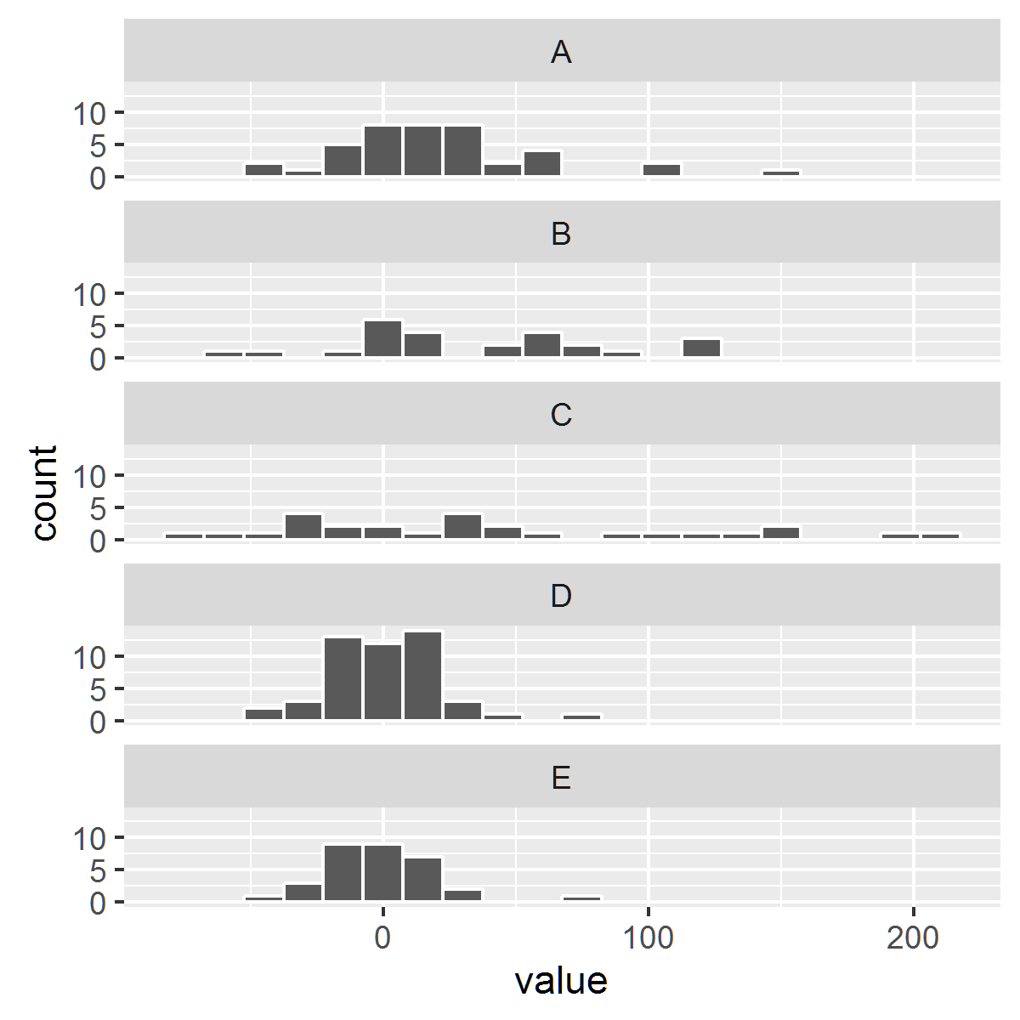
8 | - | Answers will vary but should talk about shape, center, and spread of the different graphs and data sets.
9 | - | Answers may vary, students should choose a company and justify why. They will probably choose B or C, because they have the highest means.

