L04: Preparation Assignment Worked Solutions 221B&C
Name: _____________________

Part I: Concepts Use the information in the reading assignment to complete these questions.

- What notation is used to denote the probability of an event occurring?
P(x)
- Please state and describe the three rules of probability.
1. A probability is a number between 0 and 1.
2. If you list all the outcomes of a probability experiment the probability that one of these outcomes will occur is 1. In other words, the sum of the probabilities in any probability is 1.
3. The probability that an outcome will not occur is 1 minus the probability that it will occur.
- What does it mean to be random?
When something is random, it follows a long term pattern, but we usually do not know the outcome of the next experiment.
- What does the phrase Discrete Random Variable mean?
A discrete random variable is something that varies following a specific pattern or distribution over the long run. They are discrete if they can be listed.
Part II: Application

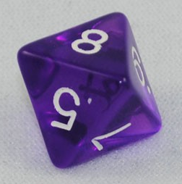
http://www.gmdice.com/media/catalog/product/cache/1/image/9df78eab33525d08d6e5fb8d27136e95/c/h/cheap-dice-purple-transparent-d8.jpg
- An eight sided die has eight possible outcomes for each roll. (1, 2, 3, 4, 5, 6, 7, or 8). Calculate the probability of rolling a number greater than 5.
P(Roll Greater Than 5) = P(6) + P(7) + P(8) = 1/8 + 1/8 + 1/8 = 3/8 or 0.375

- Calculate the probability of not getting a number greater than 5.

P(Not a Roll Greater Than 5) = 1 – P(Roll Greater Than 5) = 1 –3/8 = 5/8

