Lesson 5: Normal Distribution
Preparation
Directions: Please fill in Part I as you study the Reading Assignment. Once you finish the reading, complete the questions on Part II. You may use your notes, the key, and the help videos. Be sure to take this completed assignment to your group meeting where you can ask and help answer questions on this assignment.

Problems
Part I: Use the information in the reading assignment to complete these questions.
- Classify each of the following batting averages as either "unusual" or "not unusual." Use the z-score to make this determination.
  - 0.19
  - 0.225
  - 0.325
  - 0.335
- Find the probability that a randomly selected professional baseball player will have a batting average that is greater than 0.335.
- Provide a brief description of a Normal Density Curve. Describe the shape and the properties.
- In the following z-score formula, $z=\frac{x−μ}{σ}$ please state what each symbol stands for.
- In no less than three sentences, please define and describe the 68-95-99.7% rule.
Part II:
 | GRE Scores | Speed of Hydrogen
Mean | 150.8 | 1800
Standard Deviation | 8.8 | 600
- The mean of all quantitative scores on the GRE is 150.8 with a standard deviation of 8.8.
  - Scores on the quantitative portion of the GRE are approximately normally distributed with mean $μ$ = ________ and standard deviation $σ$ = ________.
  - What proportion of the people who take the quantitative portion of the GRE will score above 165?
  - If a student's score is the ${10}^{th}$ percentile, what would their corresponding z-score be?
  - What is the quantitative GRE score for a student who scores at the ${10}^{th}$ percentile?
- The mean speed of hydrogen at room temperature is 1800 m/s with a standard deviation of 600 m/s.
  - At room temperature the mean speed of hydrogen (H2) particles is approximately normal with a population mean of $μ$ = ________ meters per second (m/s) and a standard deviation of $σ$ = ________ m/s.
  - What is the probability that a randomly selected particle has a speed over 2500 m/s?
  - What is the probability that a randomly selected particle has a speed that is less than 2500 m/s?
  - What is the probability that a randomly selected particle has a speed that is less than 1500 m/s?
  - What is the probability that a randomly selected particle has a speed that is between 1500 and 2500 m/s?
  - What is the $3^{rd}$ quartile of the speeds of hydrogen at room temperature?
- Determine whether the data represented in these Q-Q plots are normally distributed or not. Record your answer for each graph. Justify your answer.
Plot A.
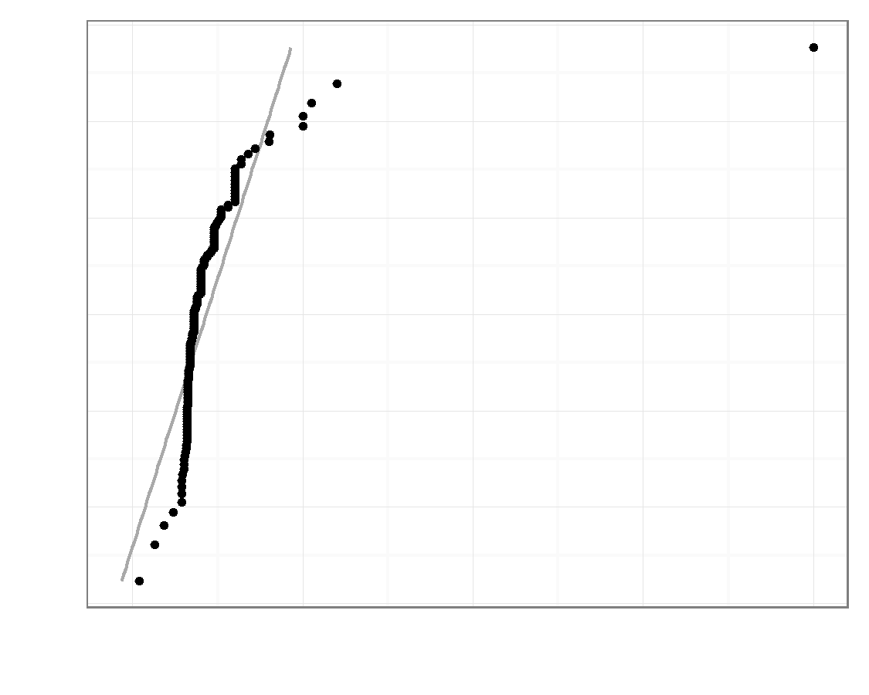
Plot B.
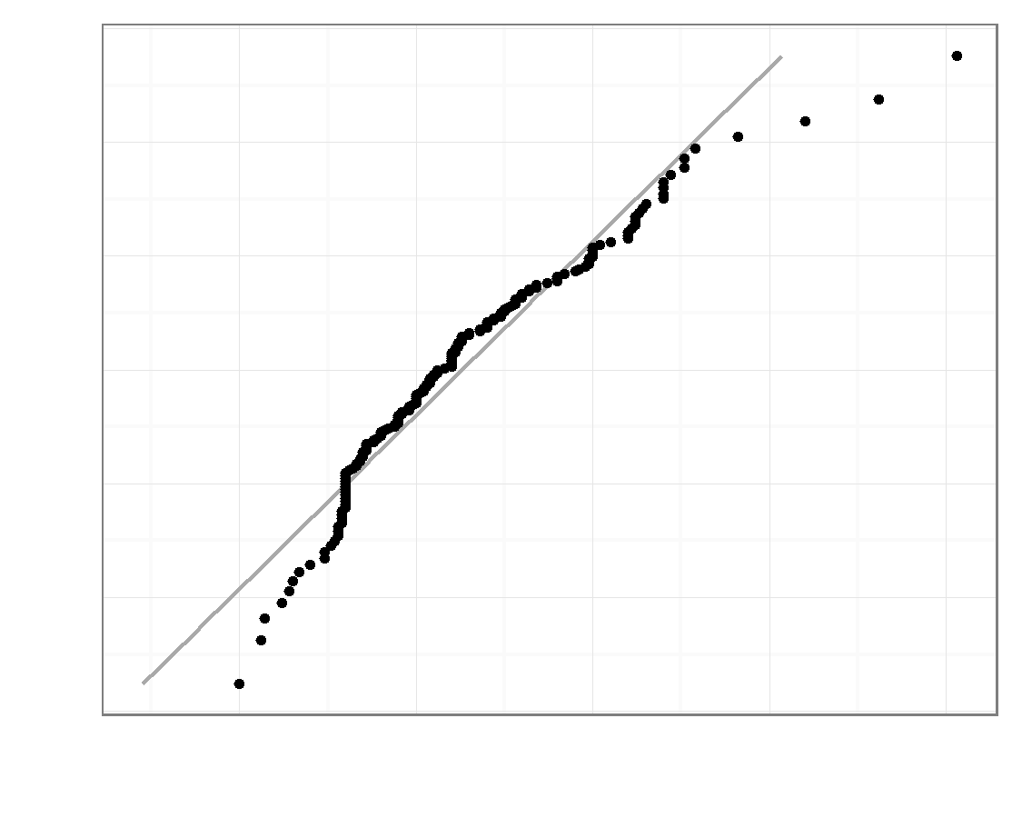
Plot C.
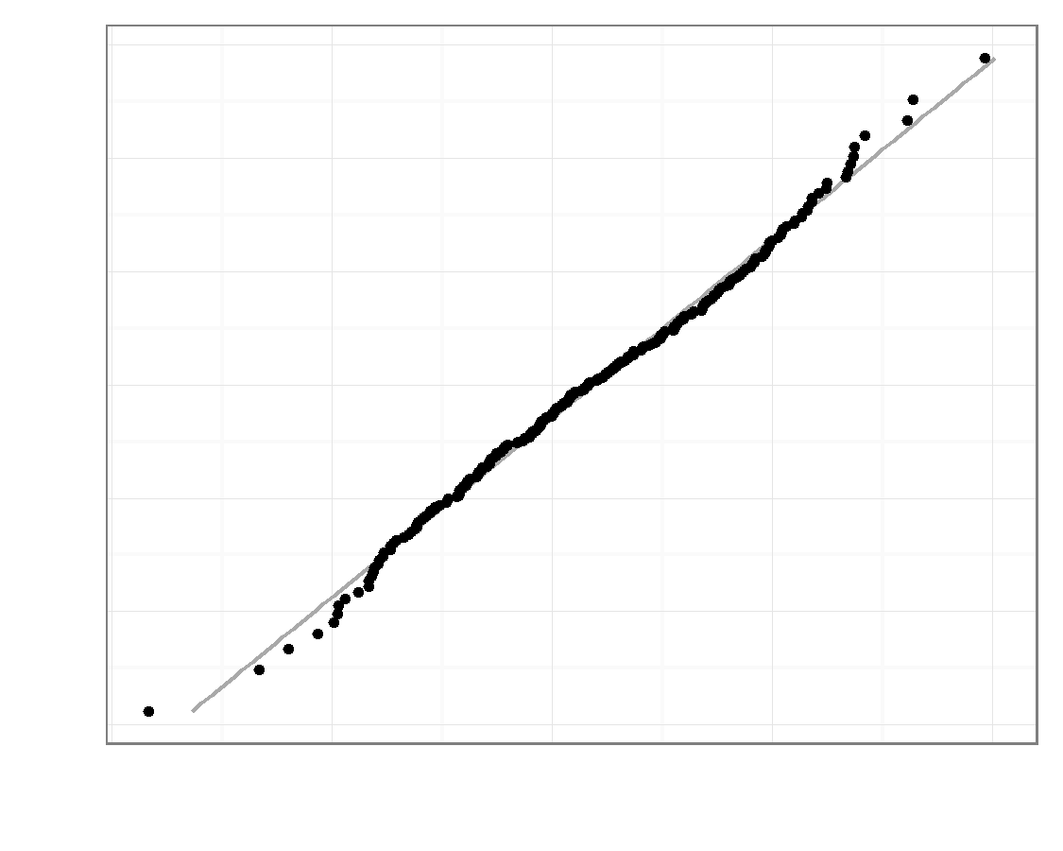
Plot D.
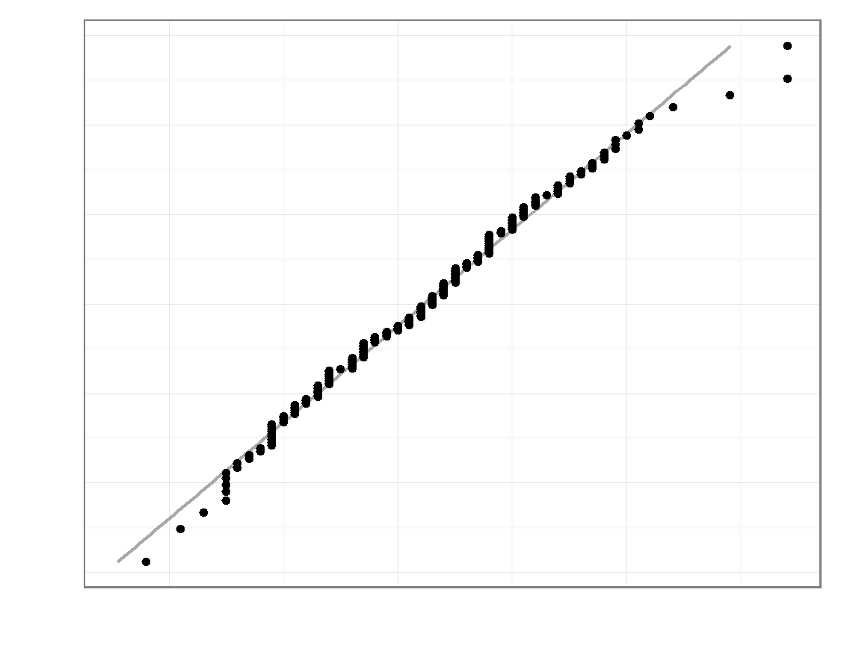
Plot E.
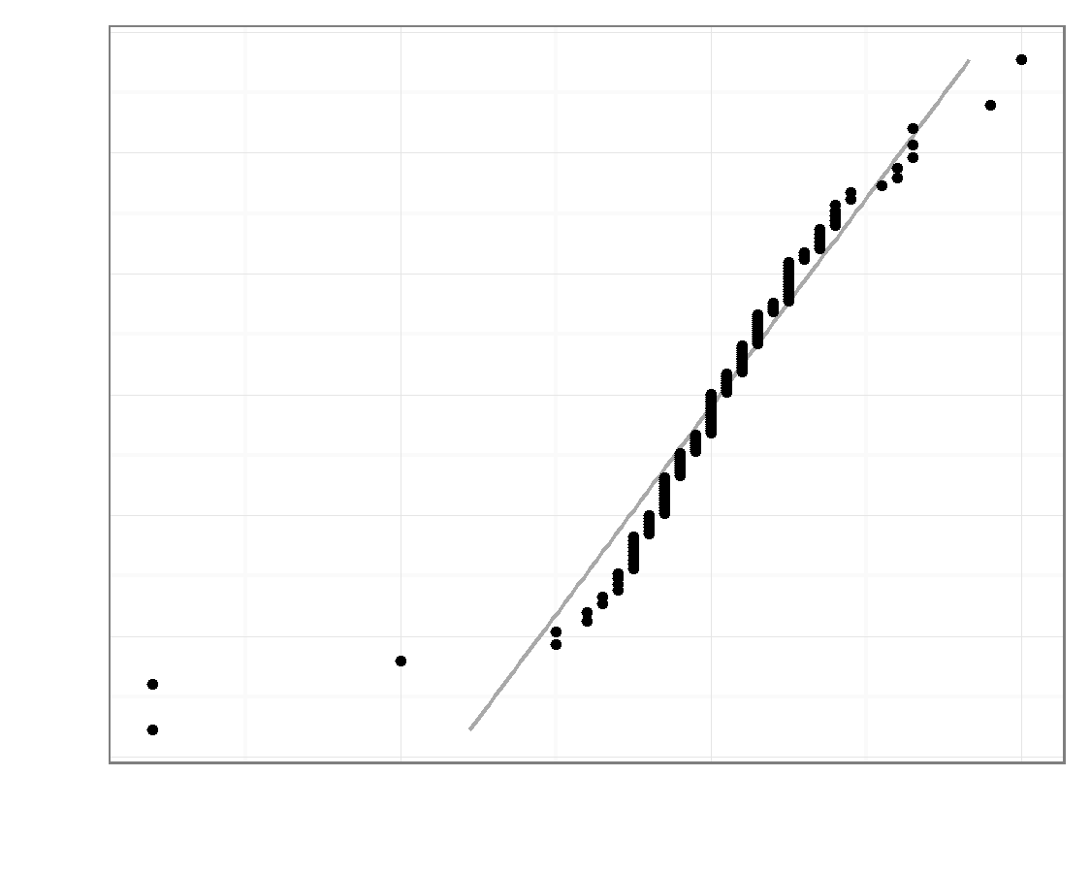
Plot F.
