L05: Preparation Assignment Worked Solutions
Name: ____________________

Part I: Use the information on the baseball batting averages given in the reading assignment to complete these questions. This information is found in Lesson 05 section “3.2.2 Baseball Averages” of the online textbook.

1. Classify each of the following batting averages as either “unusual” or “not unusual.”
a. 0.190 – Unusual (z=-2.088) – This is found by using the population mean of 0.261 and the population standard deviation of 0.034, which was found in the online textbook. Then simply use the z-score formula. $z=\frac{0.190-0.261}{0.034}$ = -2.088. This is determined to be unusual because it has a z-score that is greater than 2 and therefore more than 2 standard deviations away from the mean.

The following problems are found in the same manner as question a.

b. 0.225 – Not Unusual (z=-1.059)

c. 0.325 – Not Unusual (z=1.882)

d. 0.335 – Unusual (z=2.176)

- Find the probability that a randomly selected professional baseball player will have a batting average that is greater than 0.335.
z = (0.335 – 0.261)/0.034 = 2.176, then type the z-score into the Normal Probability Applet, in the bottom right box. Because we want to know the probability of the batting average being greater than 0.335 we shade to the right.
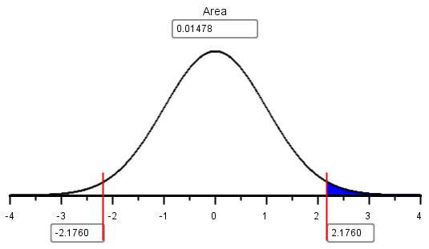
The probability that a randomly selected professional baseball player will have a batting average that is greater than 0.335 is 0.0148.
- Provide a brief description of a Normal Density Curve. Describe the shape and the properties.
The Normal Density curve is symmetric and has a bell shape. It is determined by it’s mean and standard deviation.
- In the following z-score formula, $z=\frac{(x-µ)}{σ}$ please state what each symbol stands for.
z = tells how many standard deviations away from the mean a certain observation lies. x = an observed data point. µ = mean of the population. $σ$ = standard deviation of the population.
- In no less than three sentences, please define and describe the 68-95-99.7% rule.

For any bell-shaped distribution, 68% of the data will lie within 1 standard deviation of the mean, 95% of the data will lie within 2 standard deviations of the mean, and 99.7% of the data will lie within 3 standard deviations of the mean.
This is called the 68-95-99.7% Rule for Bell-shaped Distributions. Needs to be at least three sentences.

Part II:

GRE Speed of
Scores Hydrogen
Mean 150.8 1800
Standard Deviation 8.8 600

- The mean of all quantitative scores on the GRE is 150.8 with a standard deviation of 8.8.

  - Scores on the quantitative portion of the GRE are approximately normally distributed with mean µ = __150.8______ and standard deviation σ = __8.8______.
  - What proportion of the people who take the quantitative portion of the GRE will score above 165?

Solution:
z = (x-µ)/σ = (165-150.8)/8.8 = 1.6136
So, P(X > 165) = P(z > 1.6136) = 0.05330
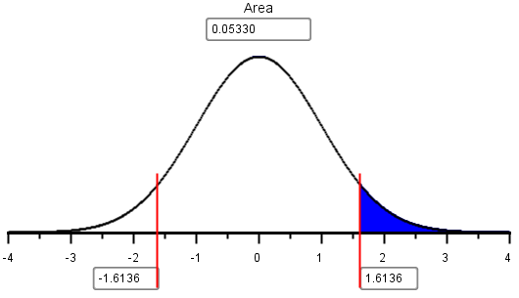
c. If a student’s score is the 10th percentile, what would their corresponding z-score be?

Solution:
This is found by shading to the left on the Normal Probability applet and then typing in 0.1 to find the z score for the 10th percentile.
z = -1.2816; this is not unusual. See question 1.
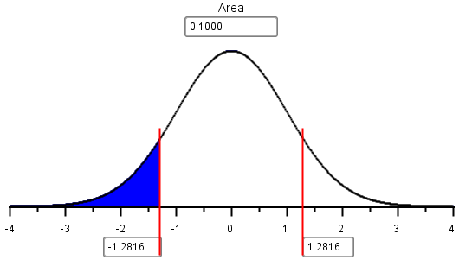
d. What is the quantitative GRE score for a student who scores at the 10th percentile?

Solution:
The z-score of the 10th percentile is z = –1.2816.
Solving the following equation for x,
z = (x – µ) / σ
we get:
x = µ+ z (σ)
Applying this equation, we get:
x = 150.8 + -1.2816 (8.8) = 139.5, which rounds to 140.
- The mean speed of hydrogen at room temperature is 1800 m/s with a standard deviation of 600 m/s.
  - At room temperature the mean speed of hydrogen (H₂) particles is approximately normal with a population mean of µ = __1800______ meters per second (m/s) and a standard deviation of
σ = __600______ m/s.

  - What is the probability that a randomly selected particle has a speed over 2500 m/s?
Solution:
z = (x-µ)/σ = (2500-1800)/600 = 1.1667
So, P(X > 2500) = P(z > 1.1667) = 0.1217
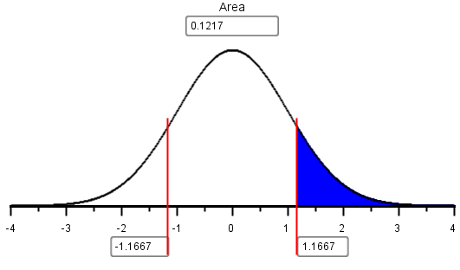

c. What is the probability that a randomly selected particle has a speed that is less than 2500 m/s?

Solution:
z = (x-µ)/σ = (2500-1800)/600 = 1.1667
So, P(X < 2500) = P(z < 1.1667) = 0.8783
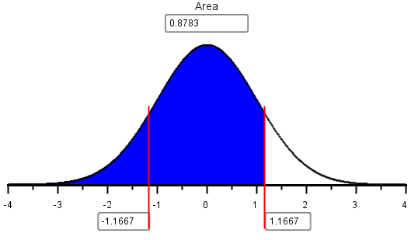
This answer is easier to get by subtracting the answer to part (a) from 1.

d. What is the probability that a randomly selected particle has a speed that is less than 1500 m/s?

Answer:
z = (x-µ)/σ = (1500-1800)/600 = –0.5
So, P(X < 1500) = P(z < –0.5) = 0.3085
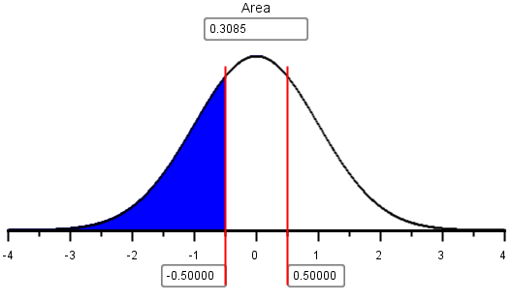

e. What is the probability that a randomly selected particle has a speed that is between 1500 and 2500 m/s?

Solution:
We subtract the probability that X < 1500
P( 1500 < X < 2500 ) = P(X < 2500) – P(X < 1500) = 0.8783 – 0.3085 = 0.5698
Note: The concept of subtracting these may be new to the students. Many groups will probably need specific help on this problem.

- What is the 3rd quartile of the speeds of hydrogen at room temperature?
Solution:
The third quartile is the 75th percentile.
This is the value of the speed that is as large or larger than 75% of the speeds.
This is illustrated with the applet below.
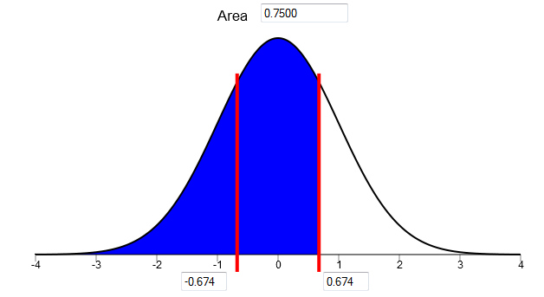
The z-score of the 75th percentile is z = 0.67449.
Substitute the values of z, µ, and σ into the equation for the z-score.
z = (x – µ) / σ
Then solve for x. Applying this equation, we get:
x = 1800 + 0.67449 (600) = 2204.4 m/s

During your Group Preparation Meeting, you will determine whether the data represented in these Q-Q plots are normally distributed or not. Record your answer for each graph. Justify your answer.
Plot A: Plot B:
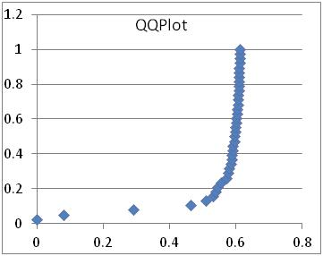 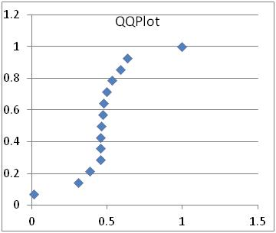
Plot C: Plot D:
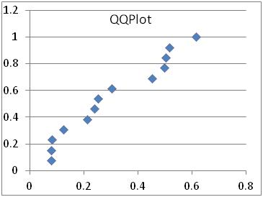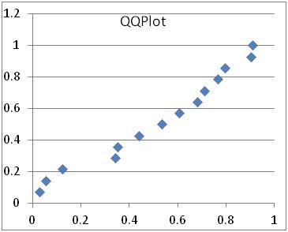
Plot E: Plot F:
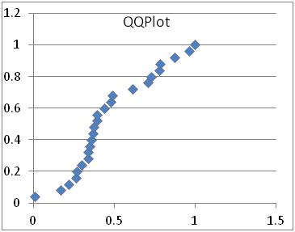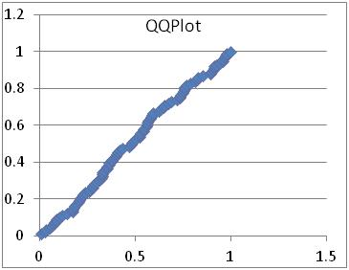
Plot A: Not normal (Additional Information: The upward curve suggests that data are skewed)
Plot B: Not normal (Additional Information: The S-shaped curve suggests that data are not normal and there are outliers)
Plot C: Normal (Additional Information: even though the points “snake” around the line, but this happens with normal distributions. The data are classified as not normal if there is a consistent, distinct curve in the Q-Q plot.).
Plot D: Normal
Plot E: Not normal (Additional Information: The downward curve suggests that data are skewed right)
Plot F: (Normal)

