Lesson 9: Inference for One Mean - Sigma Known (Hypothesis Test)
Homework

Solutions

Problem | Part | Solution
1 | - | It is the probability that you get a result as extreme, or more extreme, than the one you saw in your sample, if the null hypothesis is really true.
2 | - | The null hypothesis ($H_{o}$)
3 | - | $H_{0}:μ=69.5inches$  $H_{a}:μ<69.5inches$
4 | - | One-sided test
5 | - | Type I error
6 | - | $H_{0}:μ=98.4pounds$  $H_{a}:μ>98.4pounds$
7 | - | One-sided test
8 | - | A Type II error would be failing to reject the null hypothesis when it isn't true. In this example that would be concluding that fruit consumption hasn't increased when, in reality, it has.
9 | - | The probability of committing a Type I Error is $α$ = 0.01
10 | - | decrease the level of significance
11 | - | $H_{0}:μ=40cm$  $H_{a}:μ≠40cm$
12 | - | z = -3.75
13 | - | P-value = 0.00018
14 | - | 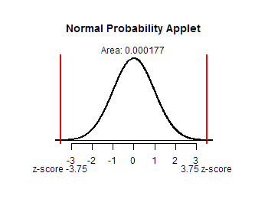
15 | - | reject the null hypothesis
16 | - | There is sufficient evidence to conclude that the mean head circumference of all two-month-old babies is different than 40 cm.
17 | $H_{0}:$ | $μ=$ 135 bushels per acre
17 | $H_{a}:$ | $μ<$ 135 bushels per acre
18 | - | z = -1.344
19 | - | P-value = 0.09
20 | - | 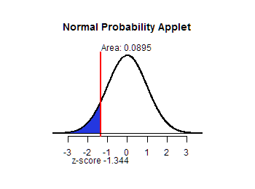
21 | - | fail to reject the null hypothesis
22 | - | There is insufficient evidence to conclude that the mean yield of corn is less than 135 bushels per acre.
23 | - | The evidence does not indicate that the production is less than 135 bushels per acre. However, it is worth keeping a close eye on the production over the next few years.

