Lesson 9: Inference for One Mean; Sigma Known (Hypothesis Test)
Preparation

Solutions

Problem | Part | Solution
1 | - | Null hypothesis
2 | - | One Side
3 | - | 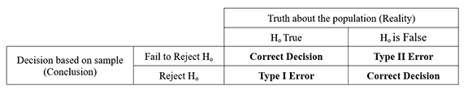
4 | - | The level of significance is a number to determine if the P-value is small enough to reject the null hypothesis. It is denoted with the Greek letter alpha ($α$). It is the probability of making a Type I Error.
5 | - | $z=\frac{\overline{x}−μ}{σ/\sqrt{n}}$
6 | - | P-value is the probability that you will observe the sample test statistic you did or one more extreme assuming the null hypothesis is true.
7 | - | We have sufficient evidence to conclude the alternative hypothesis is true.
8 | - | Answers may vary
9 | A | $H_{o}:μ=$ 529  $H_{a}:μ>$ 529
9 | B | A Type I error was committed.
9 | C | There was about a 1 in 100 or 1% chance that there would be a Type 1 Error.
9 | D | Increase the level of significance.
10 | Design the study | The researcher collects data from the population of second home buyers. It says that he randomly selects his sample from his own clients. His research question is,'Is the average age of the people buying a second investment property in my area different than the national average?'
10 | Collect the data | (Answers may vary)
10 | Describe the data | 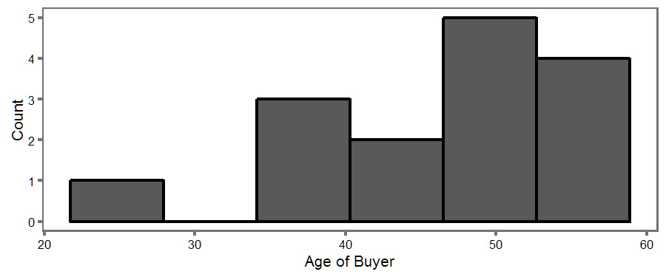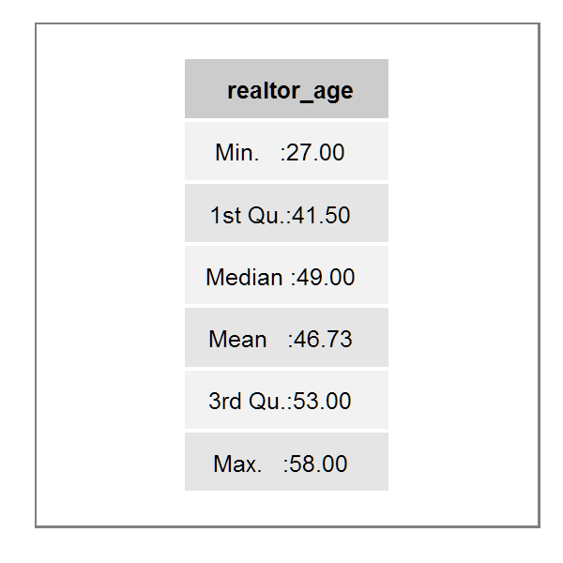
10 | Make Inference-I | 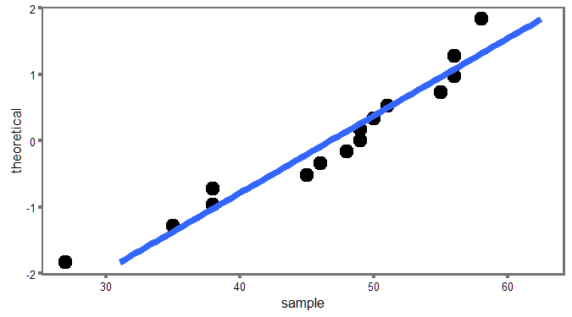
10 | Make -Inference II | $H_{o}:μ=$ 47 years old  $H_{a}:μ≠$ 47 years old
10 | Make Inference- III | $α=$ 0.05
10 | Make Inference-IV | $\frac{\overline{x}−μ}{σ/\sqrt{n}}$; z=-0.207
10 | Make Inference-V | P-value = 0.836  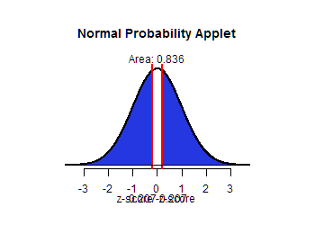
10 | Make Inference-VI | P-value is > level of significance ; 0.836 > 0.05 so we fail to reject the null hypothesis
10 | Make Inference-VII | We have insufficient evidence to conclude that the mean age of people buying a second home is different in this area, than that of the national average of 47 .
10 | Take Action | (Answers may vary) One could would suggest that the realtor keeps targeting that population of middle aged people as second home buyers.

