L09: Individual Preparation Assignment Worked Solutions 221 B&C
Directions: Please fill in Part Ι as you study the Reading Assignment. Be sure and complete both Parts I and II before you attend Group Preparation.

Part I: Concepts
- Which hypothesis between the null and alternative hypothesis is the hypothesis of “no effect” or “no difference” or “status quo” or is assumed to be true?
Null Hypothesis
(Found in Lesson 09 Section 4.1 Null and Alternative Hypotheses, “The claim representing the ‘status quo’ or the commonly held belief or the usual value is called the null hypothesis”)
- Does H_{a} below represent a one-sided or two-sided alternative hypothesis?
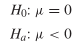
One Sided, because we only want to test if the population mean (µ) is less than 0. In a two sided alternative hypothesis would look like this: $H_{a}: μ ≠0$
Fill in the matrix below with the correct responses

 |  |  |  | Truth about the population (Reality)
 |  |  | H_{o} True |  | H_{o} is False
Decision based on sample (Conclusion) |  | Fail to Reject H_{o} | Correct Decision |  | Type II Error
 |  | Reject H_{o} | Type I Error |  | Correct Decision

You can find this table in the online textbook under Lesson 09 Inference For One Mean Sigma Known, Section 4.5
- Define the level of significance in a hypothesis test? With which Greek letter is it denoted?
The level of significance is a number to determine if the P-value is small enough to reject the null hypothesis. It is denoted with the Greek letter alpha (α). It is the probability of making a Type I Error.
- Write down the formula for computing the test statistic for the hypothesis test for a single mean when sigma is known.
$z= \frac{\overline{x}- µ}{\frac{σ}{\sqrt{n}}}$
You can find this formula in the online textbook under Lesson 09 Inference For One Mean Sigma Known (Hypothesis Test), Section 4.2

- Define the P-value. How is it used in a hypothesis test?
P-value is the probability of obtaining a test statistic at least as extreme as the one that was actually observed assuming the null hypothesis is true. This is used in a hypothesis test to see if the probability of obtaining a test statistic at least as extreme as the one observed is statistically significant. If the p-value is lower than the level of significance than we reject the null hypothesis. If the p-value is greater than the level of significance than we fail to reject the null hypothesis.
- If the null hypothesis is rejected in a hypothesis test, what is concluded about the alternative hypothesis?
We have sufficient evidence to conclude the alternative hypothesis is true.

- Think of a couple of examples where you have seen hypothesis testing in real life (open-ended).

Answers may vary.
For example: testing drinking water to see if it is within the limits for all the minerals and safe drinking levels.

Part II: Application

1. The Graduate Management Admission Test (GMAT) is used as an admission criterion in many masters of business administration (MBA) programs. The scores on the GMAT in the past have a mean score of 529. The BYU professor feels now that the score has improved within the last couple of years.
a. Determine the null and alternative hypotheses
Ho: µ = 529
Ha: µ > 529
The BYU professor feels that the scores have improved within the last couple of years, which means he believes that the mean is now greater than 529.
b. Suppose you got evidence that the null hypothesis should be rejected. However, in reality the mean score of students taking the exam is still 529. Was a Type I or Type II error committed?
A Type I error was committed. A Type I error is committed when a true null hypothesis is rejected.

c. If the analysis was done at α = 0.01 level, what is the probability of committing a Type I Error?
There was about a 1 in 100 or 1% chance that there would be a Type I Error.

d. If we wanted to decrease the probability of making a Type II error, would we need to increase or decrease the level of significance?

Increase the level of significance. The probability of making a Type I error is inversely related to the probability of making a Type II error.

2. A study by the National Association of Realtors reported in 2004 that second-home sales accounted for more than a third of residential real estate transactions. According to the report, the average age of a person buying a second home as an investment rental property was 47 years. Assuming the national standard deviation was 5, a real estate agent wants to determine if the average age of those buying investment property in his area is different than the national average. He randomly selects 15 of his clients who purchased an investment property and obtains the data shown.

27 | 49 | 56 | 45 | 49
35 | 55 | 50 | 46 | 48
38 | 58 | 51 | 56 | 38

a. Design the Study. What is the population from which the realtor obtains his data? How did he sample this population? What is the research question?
The researcher collects data from the population of second home buyers. It says that he randomly selects his sample from his own clients. His research question is “Is the average age of the people buying a second investment property in my area different than the national average?”

b. Collect the data. Name at least one way the realtor could have randomly selected his sample.
(Answers may vary)
One way a realtor could have randomly selected his sample was by a simple random sample. He would do this by putting all of his clients into a random generator like excel and then having the computer randomly select 15 of his clients.

c. Describe the data. Graph the data on a histogram. Sketch the histogram below or cut and paste your electronic copy. In a short paragraph describe the data by using at least five descriptive statistics.
(Answers may vary but here are the numerical and graphical descriptive statistics.)
This is done by using SPSS. First you must type in the 15 points of data in the Variable 1 column. Then the descriptive statistics and histogram can be found by using the command, Analyze – Descriptive Statistics – Explore. Then you can move variable 1 into the Dependent list. Next click on Plots (a tab off to the right and make sure that the histogram box is checked. This will give you the histogram of the data in your output. Finally click on OK. You should get several tables as well as a few graphs. Which should look something like this.

Descriptives
 |  |  | Statistic | Std. Error
Age | Mean |  | 46.7333 | 2.27924
Age | 95% Confidence Interval for Mean | Lower Bound | 41.8449
Age | 95% Confidence Interval for Mean | Upper Bound | 51.6218
Age | 5% Trimmed Mean |  | 47.2037
Age | Median |  | 49.0000
Age | Variance |  | 77.924
Age | Std. Deviation |  | 8.82745
Age | Minimum |  | 27.00
Age | Maximum |  | 58.00
Age | Range |  | 31.00
Age | Interquartile Range |  | 17.00

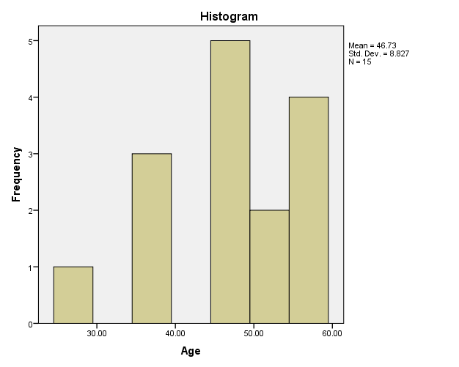

d. Make inference.

- Check the requirements. Since there are only 15 pieces of data, what will you need to check?
Make a QQ plot of the data to check for normality.
This is done by also using SPSS. It is the same command as before Analyze – Descriptive Statistics – Explore, however this time make sure you click the plots tab and make sure that normality plot is checked. This will make you a QQ-plot of the data. It should look something like this.
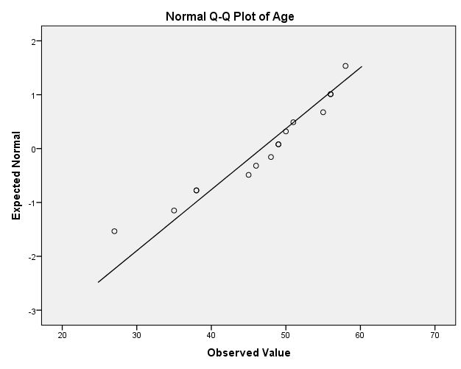

- State the null and alternative hypothesis. (Is this a one or two-tailed test?)
Ho: µ = 47
Ha: µ ≠ 47
This is a two tailed test. You can look back at the researchers question to make this decision. It says, “a real estate agent wants to determine if the average age of those buying investment property in his area is different than the national average.” The key word here is different than.
- Let the level of significance be α = 0.05

- Compute the test statistic. What is the formula to be used? (Recall our test statistic will be a z-score.) After writing down the general formula, input the numbers you will use. Show this work. Finally, use Excel or a calculator to compute your test statistics.
$$z_{o}=\frac{ \overline{x}- μ}{\frac{σ}{√n}}$$
$z_{o}= \frac{46.73-47}{\frac{5}{\sqrt{15}}}$
z = - .20910

- Compute the P-value. First, sketch a standard normal curve; graph your test statistic along the horizontal axis. Shade the appropriate area under the curve. Use the Normal Applet to compute the area under the curve. This area is the P-value.
P-value = 0.8344
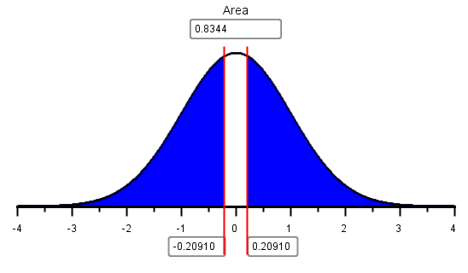
P-value
Two tailed test, shade both sides
Input z-score here

- Compare the P-value to the level of significance (the α-level). Do we reject the null hypothesis or fail to reject the null?

P-value is > level of significance ;0.8344 > 0.05 so we fail to reject the null.

- State your conclusions in terms of the alternative hypothesis
We have insufficient evidence to conclude that the mean age of people buying a second home is different in this area, than that of the national average of 47.
e. Take Action.
What action—if any—do you suggest the realtor to take based on your statistical conclusions?
(Answers may vary)
One possible suggestion could be, I would suggest that the realtor keeps targeting that population of middle aged people as second home buyers.

