Lesson 11: Inference for One Mean; Sigma unknown (Hypothesis Test)
Preparation

Solutions

Problem | Part | Solution
1 | - | - Symmetrical  - Mean of 0  - Exact shape depends on the degrees of freedom  - Bell Shaped  - More area in the tails than the standard normal distribution
2 | - | $df=n−1(that is sample size−1$)
3 | - | $$\overline{x}−t^{*}×\frac{s}{\sqrt{n}},\overline{x}+t^{*}×\frac{s}{\sqrt{n}}$$
4 | - | - Sigma is not known  - We compute a t-score from the Student t-distribution rather than a z-score from the normal distribution. (We cannot use the Normal Applet to compute t-scores.)  - We must now consider degrees of freedom for the t-distribution where the normal distribution did not have degrees of freedom.
5 | - | $$t=\frac{\overline{x}−μ}{s/\sqrt{n}}$$
6 | - | - A simple random sample was drawn from a population.  - $\overline{x}$ is normally distributed.
7 | - | The mean is 46.733. The standard devation is 8.827
8 | - | It is a random sample from a population. The $\overline{x}$’s are normally distributed
9 | - | (41.845 , 51.622)
10 | - | (39.948 , 53.518)
11 | A | (41.845 , 51.622)
11 | B | (39.948 , 53.518)
12 | - | The margin of error for the confidence interval is smaller for a 95% confidence level than a 99% confidence level.
13 | A | $H_{o}:μ=47$  $H_{a}:μ≠47$
13 | B | t = -0.117
13 | C | df = 14
13 | D | 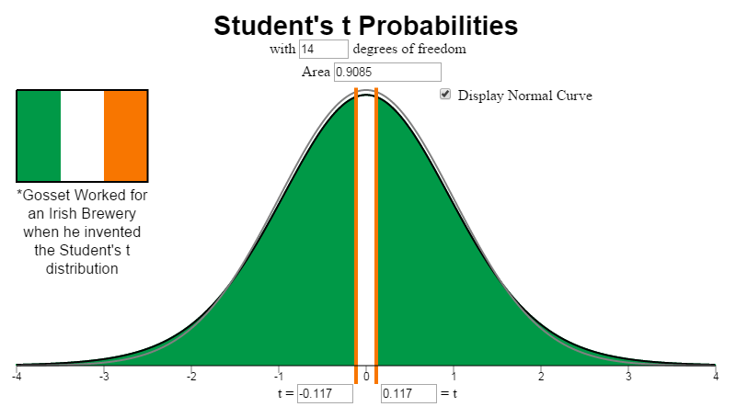
13 | E | P-value = 0.909
13 | F | fail to reject the null hypothesis
13 | G | We have insufficient evidence to conclude that the mean age of this realtor’s customers who are buying second homes, is different than the national average.

