Lesson 12: Inference for Two Means (Paired Data)
Preparation

Solutions

Problem | Part | Solution
1 | - | Usually matched pairs are data taken from one population where a pair of observations is drawn on the same individuals selected for the sample, such as a pre-test and post-test.
2 | - | open ended
3 | A | After implementing the new loading/unloading procedure, is the mean wait time different than the wait time before?
3 | B | $H_{o}:μ_{d}=$ 0  $H_{a}:μ_{d}≠$ 0
4 | - | The researcher collected assembly times (in minutes) from 9 factory workers before the change. Then he collected the assembly times for those same 9 workers after the change in procedure had been implemented.
5 | - | The paragraph should include:  - $\overline{d}=±$ 1.056 (depending on difference taken)  - $s_{d}=$ 2.596  - $n=$ 9  - One histogram of the differences and one histogram for each of the original data sets with clear lables.  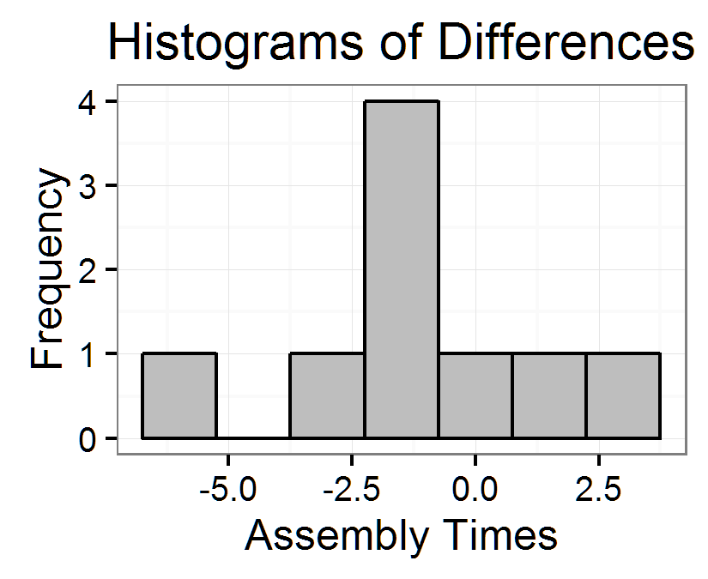  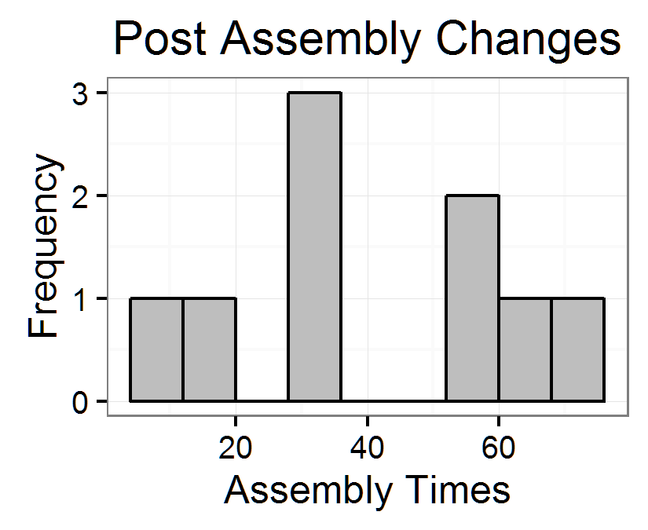  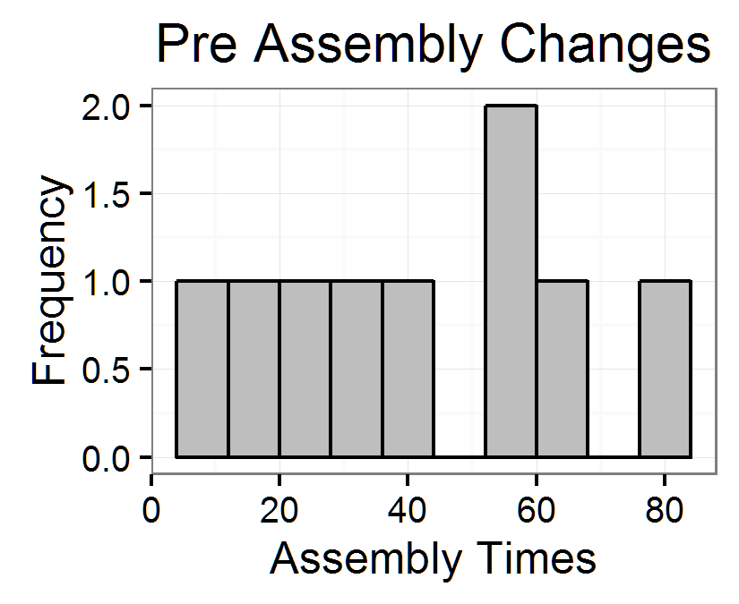
6 | A | A two tailed paired-sample t-test for means is the appropriate hypothesis test to perform.
6 | B | That the sample mean of the differences comes from a normal distribution and we assume a simple random sample of the population.
6 | C | We assume a simple random sample of the population. $n<30$ so we would need to make a QQ plot in order to test the normality of the data.  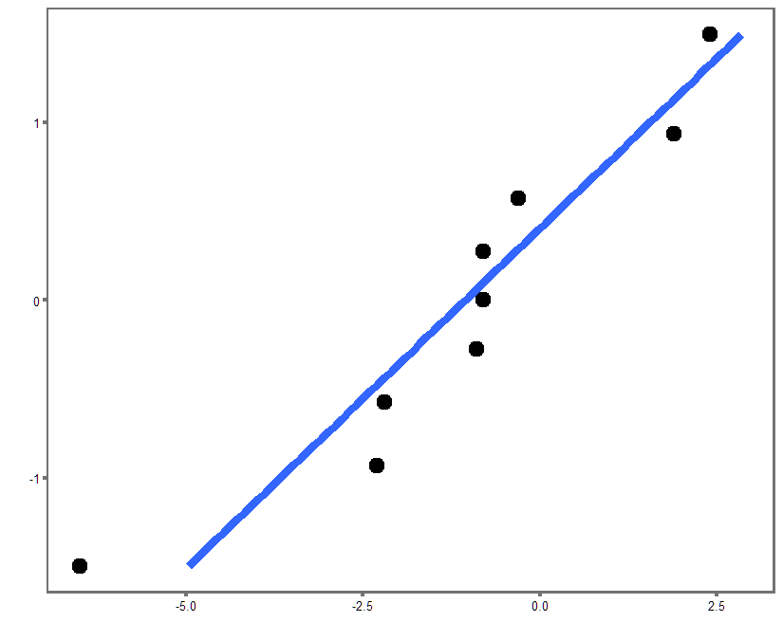  The differences may not by normally distributed, it is hard to tell with so few samples. We will continue with our assumption of normality.
6 | D | $t=1.22$ or $t=−1.22$
6 | E | $df=8$
6 | F | $P-value=0.257 P-value>α$
6 | G | $P-value>α$, therefore we fail to reject the null hypothesis the null hypothesis.
6 | H | We have insufficient evidence to say that the time to make 100 products is any different after the implementation of the new assembly procedure.
6 | I | We would create a 95% confidence interval using the t-distribution. (-0.9397,3.0508) or (-3.0508,0.9397) depending on difference calculated
7 | - | You should describe how they need to find another way to reduce the time, because this particular plan did not make a statistically significant difference.

