L12: Preparation Assignment Worked Solutions 221B&C

Part I: Concepts
- What does it mean to have Matched Pair data?
Usually matched pairs are data taken from one population where a pair of observations is drawn on the same individuals selected for the sample, such as a pre-test and post-test.
- What are the differences in the hypothesis tests between a One Sample t (σ unknown) and Matched Pairs t (open-ended)?
Some possible differences between a One Sample t test and a Matched Pairs t test are:
- In Matched Pairs a pair of observations is drawn from one population, while in a one sample t test only one observation is drawn.
- In a matched pairs test we are testing the differences between the two observations, which means we will need to subtract and make a new variable of differences before continuing on with the rest of the test.

Part II: Application
Matched Paired t Procedure - A manager at a factory feels that the amount of time that his workers spend doing their part in the assembly line is too long. To determine if a new assembly procedure is effective in reducing the time, he measures the amount of time (in minutes) nine of his workers take to complete 100 products. After implementing the new procedure, he again measures the amount of time (in minutes) the same nine workers take to complete 100 products, and obtains the following data: He wants to know if the mean assembly time is different and used the level of significance of α = 0.05. (Use this data link “FactoryAssemblyTimes-sim”, which will take you to the data page of the Online Textbook.)

- Design the Study:
- What is the research question?
After implementing the new loading/unloading procedure, is the mean time it takes to make 100 products different than the mean time to make 100 products before the new procedure?

- State the null and alternative hypothesis.
$$H_{o}: μ_{d }=0$$
$$H_{a}: μ_{d }≠0$$
This is a two tailed test because the research question asks if the mean time it takes to make 100 products is different than the mean time to make 100 products before the new procedure was implemented. The key word here is different.
- Collect the Data:
- Describe the data collection procedures.
The researcher collected assembly times (in minutes) from nine factory workers before the change. Then he collected the assembly times for those same nine workers after the change in procedure had been implemented.
- Describe the Data:
- In a short paragraph use summary statistics to describe the data. After the paragraph insert an appropriate and well labeled graph to illustrate the data.
Here you should have a paragraph to summarize the statistics. You should include:
$\overline{d}=±1.056$ (depending on if you subtracted post from pre or pre from post), $s_{d }=2.596$ , n = 9. Also, they could include one histogram of the differences and one histogram each of the original data sets. Be sure your graphs are clearly labeled.
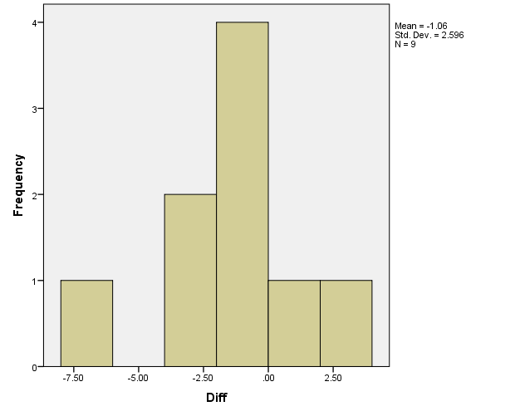
- You can obtain these summary statistics by using SPSS. First we have to compute the differences between the pre-test and post-test. This is done by using SPSS commands Transform – Compute Variable. In the target variable box you can type in the title of the new column which I chose to call “Difference”. In the "Numeric Expression" box, you will tell SPSS how to determine the values for the new variable. To subtract one column of data from another, do the following: Move the first variable into the "Numeric Expression" box, in this case PostAssemblyChange. You can type a subtraction sign "-" or you can click on the corresponding button in the dialog box. Then move the second variable into the "Numeric Expression" box, in this case PreAssemblyChange. Now, the "Numeric Expression" box should show the subtraction operation you want to conduct. For example, "Post - Pre".
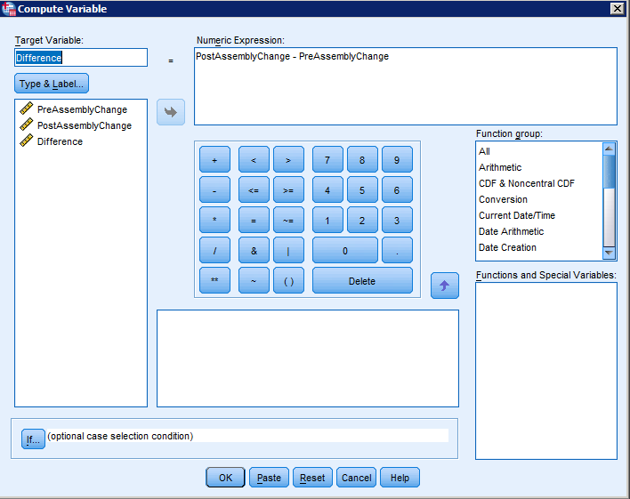
Now you can use this Difference column to find your descriptive statistics.

- Make Inferences:
- What type of hypothesis test is appropriate?
A two tailed, paired-sample t-test for Means is the appropriate hypothesis test to perform. A good clue for this is that we are comparing a pre-test to a post-test of the same 9 factory workers.
- What are the requirements for this test?
That the sample mean of the differences comes from a normal distribution
- Compute the differences between the two times and determine if the requirements are met for this test? Explain your answer.
We assume a simple random sample of the population. n < 30 so we would need to make a QQ plot in order to test the normality of the data. The differences are not very normally distributed, so the requirement is not met.
A QQ plot is made by using SPSS commands Analyze – Descriptive Statistics – Explore. Move the difference variable into the Dependent List. Under the plots tab make sure that Normality plots with test is checked. Then click on OK.
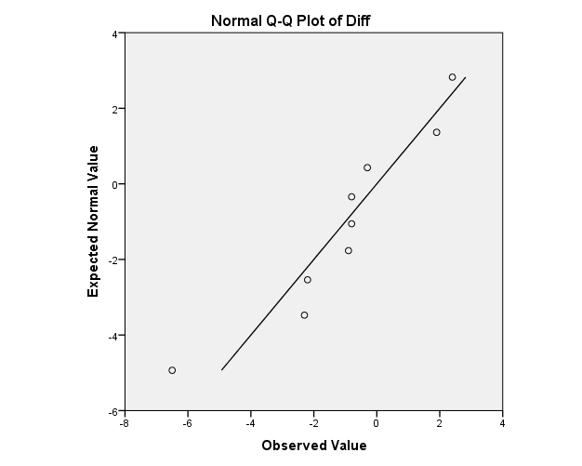
- Continue with the test regardless of what you found in part c. Compute the test statistic.
t = 1.22 or -1.22
This is computed by doing a One Sample T-test using the difference variable column. Therefore in SPSS we use the commands Analyze – Compare Means – One Sample T-test. Move the Difference Variable into the Test Variable box, and leave the Test Value as 0. Then click on OK. This should give you the following output.

One-Sample Test
 | Test Value = 0
 | t | df | Sig. (2-tailed) | Mean Difference | 95% Confidence Interval of the Difference
 |  |  |  |  | Lower | Upper
Difference | -1.220 | 8 | .257 | -1.05556 | -3.0508 | .9397

- State the degrees of Freedom.
df = 8
- Compute the P-value and compare it to the alpha level.
P-value = 0.257 P-value > α
- Make a decision. Do you reject the null hypothesis or fail to reject it?
P-value > α, therefore we fail to reject the null hypothesis.
- Present your conclusions in the form of an English statement.
We have insufficient evidence to say that the time to make 100 products is any different after the implementation of the new assembly procedure.

- Rather than testing a hypothesis, now say you just wanted to estimate the mean difference between wait times at the 95% level. What would you do? Do it and paste your results below.

We would create a 95% confidence interval using the T-distribution.
(-3.051, 0.940) or (-0.940, 3.051) depending on which way you subtracted the data.
This is done by using the same SPSS commands as above. As you can see in the output table above it includes the 95% confidence interval.
- Take Action
In a short paragraph describe the action you feel should be taken based on the statistical results above.
You should describe how they need to find another way to reduce the time, because this particular plan didn’t make a statistically significant difference.

