Lesson 13: Inference for Two Means; Independent Samples
Homework

Solutions
Problem | Part | Solution
1 | - | Samples are dependent (or represent paired data) if knowing which subjects will be in the first group determines which will be in the second group. If knowing which subjects are in the first group gives you no information about the second group, we say the samples are independent.
2 | - | a
3 | - | 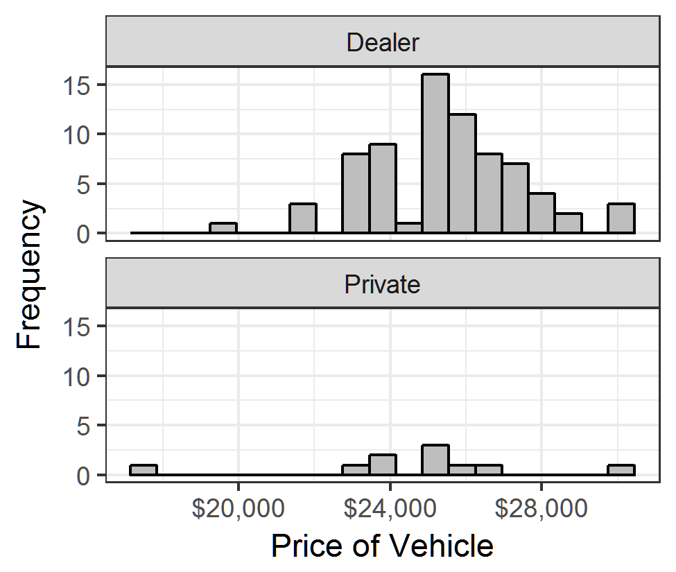
4 | - | The two histograms look different, but the means look fairly close.
5 | - | a. We are told that the data was collected using a SRS  b. The sample size for dealers is large, so we can assume that it is normally distributed. The sample size for private sellers is small, with a sample of n = 10 . A Q-Q Plot will help us know if the data are normally distributed.  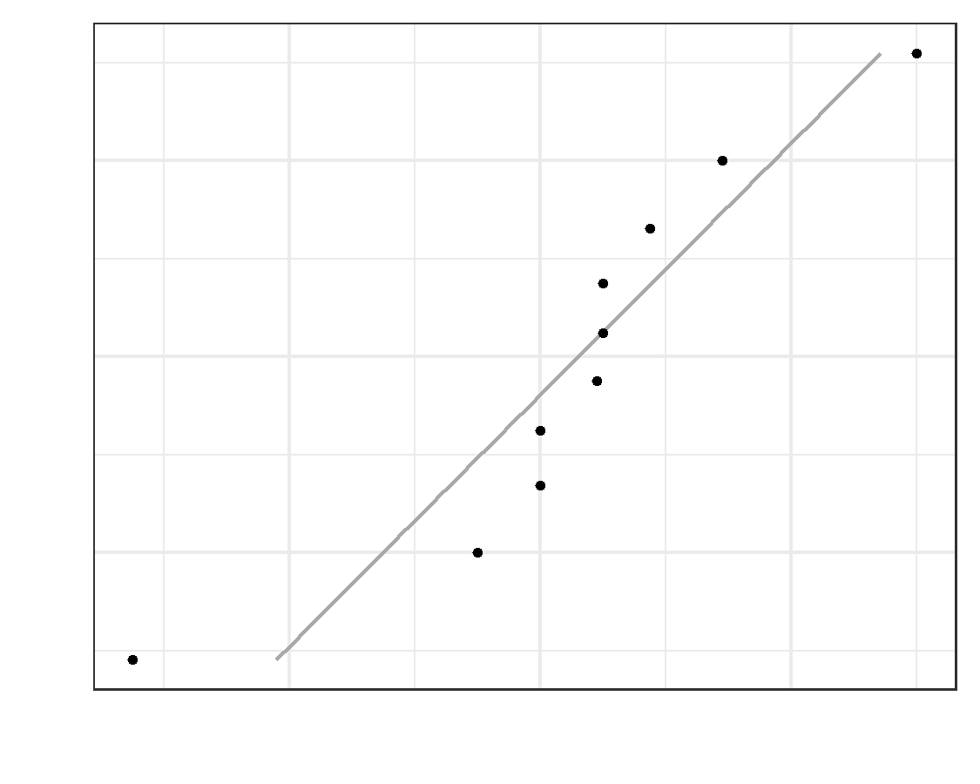  These data are clearly not normally distributed and n = 10 is a very small sample size. Therefore, we have not met the requirements. However, we will proceed with caution and realize that our confidence interval and p-value are not accurate and the conclusions are more suspect than they would be if we had met the requirements.
6 | - | (-1458.12, 3114.336) We are 95% confident that the true difference of the mean car prices between dealers and private sellers is between -1458.12 and 3114.336.  Please note, if you put the two groups in the reverse order, you will have a confidence interval with the opposite signs (-3114.336, 1458.12). Either answer is acceptable.
7 | - | Yes. Since the confidence interval contains 0, it is plausible that the true difference of the means is 0, meaning that the mean car prices are the same for dealers as for private sellers. There is inconclusive evidence that there is a difference.
8 | - | 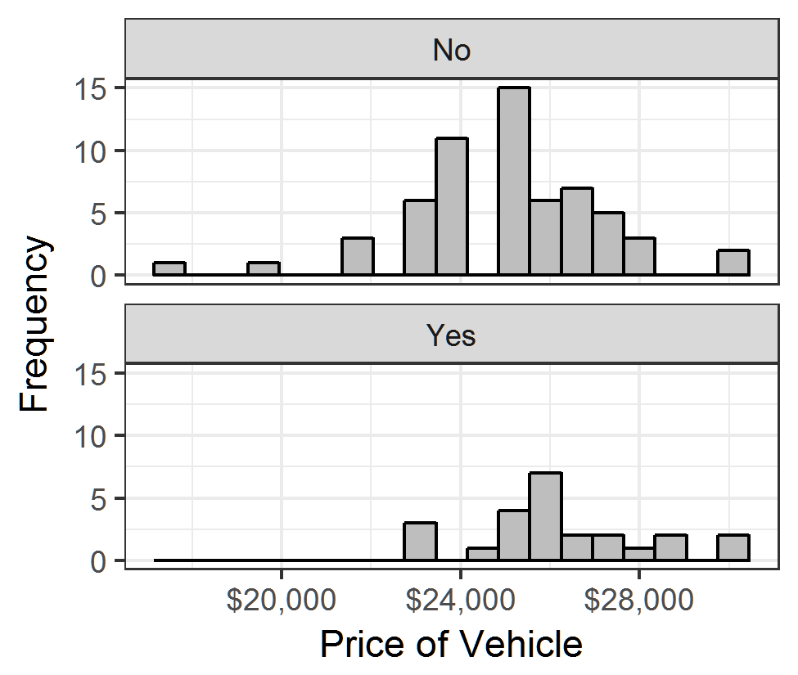
9 | - | Answers will vary
10 | - | a. We are told that the data was collected using a SRS.  b. The sample size for non-certified cars is large, so we can assume that it is normally distributed. With a sample size of n = 24 for certified cars, it is likely large enough to assume a normal distribution, but a Q-Q Plot will help us know more confidently.  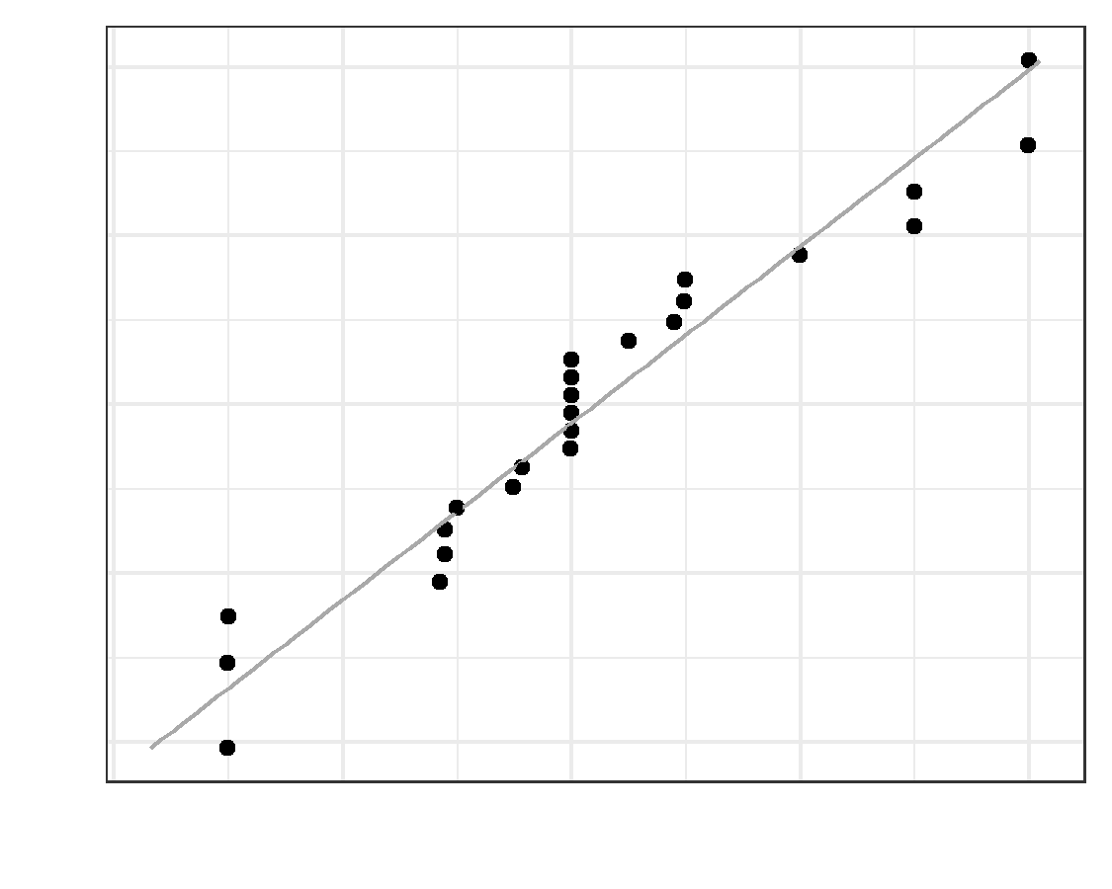  These data are approximately not normal.
11 | - | (-2204.9, -241.417) We are 95% confident that the true difference of the mean car prices between dealers and private sellers is between -2204.9 and -241.417.  Please note that if you put the two groups in the reverse order, you will have a confidence interval with the opposite signs (241.417,2204.9). Either answer is acceptable.
12 | - | No. Since the confidence interval does not contain 0, it is plausible that the mean car prices are different for certified cars than from non-certified cars.
13 | - | $H_{o}:μ_{1}=μ_{2}$  $H_{a}:μ_{1}>μ_{2}$
14 | -
15 | - | These requirements are the same as the ones used when we created the confidence interval in question 10.
16 | - | ${\overline{x}}_{1}=26207.208$  $s_{1}=1957.552$  $n_{1}=24$  ${\overline{x}}_{2}=24984.05$  $s_{2}=2169.061$  $n_{1}=60$
17 | - | $t=2.507$  $df=46.743$
18 | - | $p-value=0.008$
19 | - | $p-value=0.008<0.05=α$  reject the null hypothesis.
20 | - | There is sufficient evidence to suggest that the price of certified cars is greater than the price of non-certified cars.
21 | - | $H_{o}:μ_{1}=μ_{2}$  $H_{a}:μ_{1}≠μ_{2}$
22 | - | $t=0.15$ (or, if you assigned the groups differently, $t=−0.15$)  $df=789.482$
23 | - | $p-value=0.88$
24 | - | $p-value=0.88>0.05=α$  , fail to reject the null hypothesis.
25 | - | There is insufficient evidence to suggest that there is a difference in patient satisfaction between doctors and nurse practitioners.

