Lesson 13: Inference for Two Means (Independent Samples)
Preparation

Solutions

Problem | Part | Solution
1 | - | There is no pairing between the two groups. Group 1 does not determine Group 2.
2 | - | 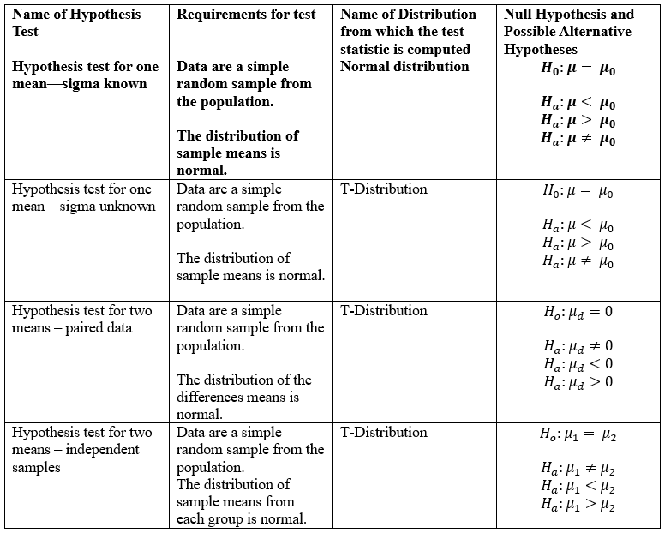
3 | A | Is there a difference between the mean wages of BYU-Idaho male students and female students?
3 | B | $H_{o}:μ_{1}=μ_{2}$  $H_{a}:μ_{1}≠μ_{2}$
4 | - | Students from one of the Math Department professor’s classes took a survey which asked how much they make as an hourly wage.
5 | - | -Males: $\overline{x}=11.935$, $s=10.491$, $n=85$  - Females: $\overline{x}=9.759$, $s=3.169$, $n=91$  - You should also include two histograms here, one for the men and one for the women.  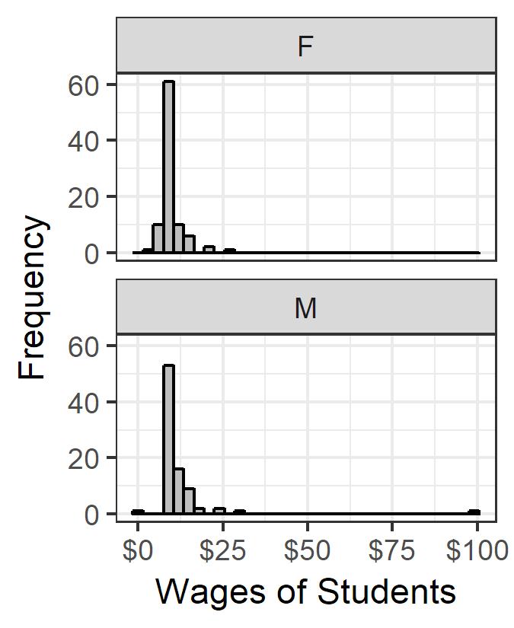
6 | A | Independent Samples Hypothesis test
6 | B | -The sample size is large for each sample so we can assume normality.  - It was not a simple random sample.
6 | C | $t=±1.836$
6 | D | $df=98.263$
6 | E | $P-value=0.069$, $α=0.05$, $p-value>α$
6 | F | fail to reject the null hypothesis
6 | G | We have insufficient evidence to say that there is a difference between wages of male and female BYU-Idaho students.
6 | H | (-0.176, 4.529) or (-4.529, 0.176)
6 | I | -We are 95% confident that the true difference in mean wages between women and men at BYU-Idaho is somewhere between $-0.18 and $4.53, or $-4.53 and $0.18.  - We can also see that there is insufficient evidence using the confidence interval method because zero is included in our confidence interval.
7 |  | Answers may vary

