Lesson 16: Describing Categorical Data; Proportions; Sampling Distribtion of a Sample Proportion
Homework

Solutions
Please note that the steps show rounded numbers, but that the final answers to the problems are calculated without rounding.
Problem | Part | Solution
1 | - | A pie chart is used for categorical data. Each slice represents a part of a whole. A histogram, on the other hand, is used for quantitative data. It is a visual representation of the spread of a set of data.
2 | - | 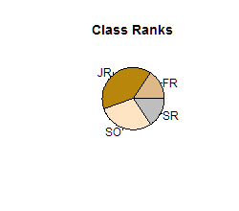
3 | - | 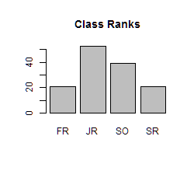
4 | - | 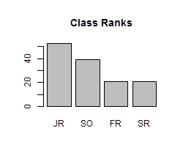
5 | - | The sample proportion $\overset{^}{p}$ will be approximately normal when $n$ is large. How do we know if $n$ is large? We will conclude that $n$ is large when $np≥10$ and $n(1−p)≥10$
6 | - | n = 100
7 | - | The sample proportion $\overset{^}{p}$ will be approximately normal when:  $np≥10$ and $n(1−p)≥10$  $1000(0.528)=528≥10$ and $1000(1−0.528)=472≥10$  Since both conditions are true, we conclude that $n$ is sufficiently large so that $\overset{^}{p}$ will be approximately distributed.
8 | - | The sampling distribution of $\overset{^}{p}$ is approximately normal with mean $p=0.528$ and $standard deviation of 0.016$.
9 | - | $z=−1.774$
10 | - | $P(Z=−1.774)=0.038$
11 | - | The sample proportion $\overset{^}{p}$ will be approximately normal when:  $np≥10$ and $n(1−p)≥10$  $4040(0.5)=2020≥10$ and $4040(1−0.5)=2020≥10$  Since both conditions are true, we conclude that $n$ is sufficiently large so that $\overset{^}{p}$ will be approximately distributed.
12 | - | The sampling distribution of $\overset{^}{p}$ is approximately normal with mean $p=0.5$ and $standard deviation of 0.008$.
13 | - | $P(Z=0.881 or Z=−0.881)=0.378$

