Lesson 16: Describing Categorical Data (Proportions)
Preparation

Solutions
Please note that the steps show rounded numbers, but that the final answers to the problems are calculated without rounding.
Problem | Part | Solution
1 | - | b. Pie Charts  d. Bar Charts
2 | - | $\overset{^}{p}=\frac{x}{n}$  n = total sample size  x = number of individuals in sample with the characteristic you are focusing on.
3 | - | P or the population proportion
4 | - | $Standard Deviation of \overset{^}{p}=\sqrt{\frac{p(1−p)}{n}}$  n = total sample size  p = the true population proportion, which is also the mean of the distribution of $\overset{^}{p}$
5 | - | Answers may vary: Categorical data groups the individuals in your study into categories, while numerical data assigns numbers to the individuals in your study. These numbers are a subset of the real numbers and can be discrete or continuous.
6 | - | 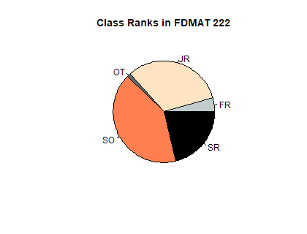
7 | - | 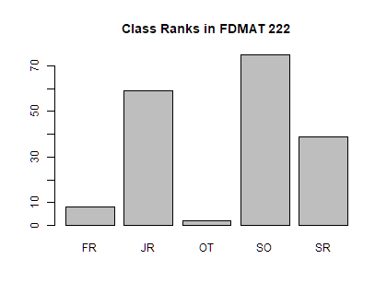
8 | - | Your answers could vary. You could’ve used proportions to describe the data, described the data in words, or displayed a frequency table.  Freshman: Count=8, $\overset{^}{p}$=0.0437  Sophmore: Count=75, $\overset{^}{p}$=0.4098  Junior: Count=59, $\overset{^}{p}$=0.3224  Senior: Count=39, $\overset{^}{p}$=0.2131  Other: Count=2, $\overset{^}{p}$=0.0109
9 | A | The mean is 7% or 0.07 in this sample and the standard deviation is 0.0093
9 | B | z= 1.073
9 | C | Area = 0.1416

