L16: Preparation Assignment Worked Solutions 221B&C

Part I: Concepts

- Pick from the list of graphs below, which graphs you can use to describe categorical data:
  - Histograms
  - Pie Charts
  - Boxplots
  - Bar Charts

- When given a sample, what is the formula to compute $\hat{p}$? Explain which each variable stands for in your formula.
$\hat{p}= \frac{x}{n}$ n = total sample size and x = number of individuals in sample the with the characteristic you are focusing on.

- What is the mean of the sampling distribution of the samples proportion $\hat{p}$? (State this answer in words—not just a symbol.)

P or the population proportion

- What is the standard deviation of the sampling distribution of the samples proportion $\hat{p}$? (You may state this answer in symbols. Please include what each symbol in your formula stands for.)

$Standard Deviation of \hat{p}= \sqrt{\frac{p(1-p)}{n}}$ where n = total sample size and p = the true population proportion, which is also the mean of the distribution of $\hat{p}$

- What is the difference between categorical and quantitative data? What are a couple of examples of categorical data (open-ended)?
Answers may vary.
Categorical data groups the individuals in your study into categories, while numerical data assigns numbers to the individuals in your study. These numbers are a subset of the real numbers and can be discrete or continuous.

Part II: Application
- Open the file: Class Survey. Sav. Create a pie chart for Class Rank. Label it. Post it here.
Making a pie chart in SPSS is done by the following commands, Graphs – Legacy Dialogs – Pie. Then click on Define. Next move over the variable you want to make a pie graph of into the “Define Slices By” box, which in this case is the variable Rank. Then click on OK. This will give you the following pie chart.
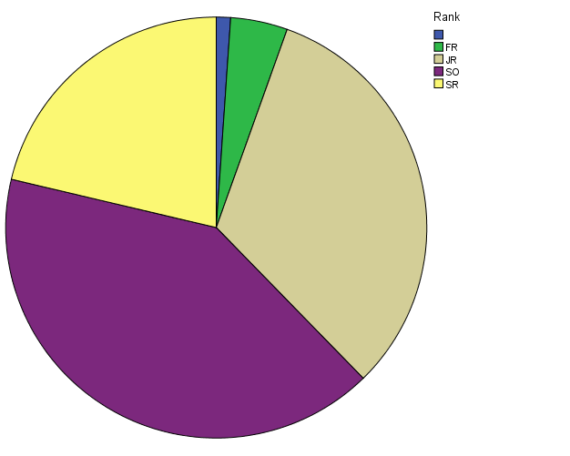

- Next create a bar graph for Class Rank. Label it. Post it here. (222 and 223 students must use SPSS)

The only difference in making a pie chart and a bar chart is instead of selecting pie chart when you do Graphs – Legacy Dialogs… chose Bar. Then click “Define”, and move the variable Rank into the Category Axis box. Then click on OK.

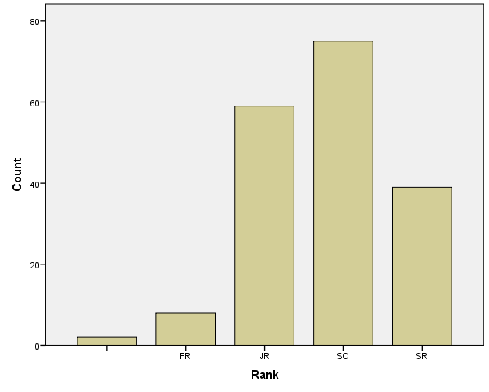

- Use at least five descriptors to describe the data above.
These answers may vary. Students may use proportions to describe the data. They may also describe their sample with words, etc. They may use a frequency table.
Examples of proportions:
- $\hat{p}$ _{Fr} = 0.0437
- $\hat{p}$ _{Soph} = 0.4056
- $\hat{p}$ _{Jr} = 0.3224
- $\hat{p}$ _{Sr} = 0.2131
Frequency Table
Class | Count | Proportion
Freshman | 8 | 0.0437
Sophomore | 75 | 0.4056
Junior | 59 | 0.3224
Senior | 39 | 0.2131
Other | 2 | 0.0109
Total | 183 | 1.0

The proportions are found by dividing the count for each class by the total.
- Seven Percent is the true unknown percent of the population do not have traditional phones and instead rely on cell phones (7% is p). Suppose a random sample of 750 telephone users is obtained. What is the probability that more than 60 phone users (8%) in the survey use only cell phones?

  - What is the “mean” and standard deviation of the sampling distribution based on 750 telephone users?

The mean is 7% or 0.07 in this sample as is given in the problem and the standard deviation is 0.0093, which is found by using the equation $Standard Deviation of \hat{p}= \sqrt{\frac{p(1-p)}{n}}$
$$=\sqrt{\frac{0.07(1-0.07)}{750}}$$
$$=0.0093$$

  - Convert (standardize) the values of (p-hat) using the standard normal variable Z (Find the Z-Score)

Z = 1.075

This is done by using the equation z = $\frac{value-mean}{standard deviation}$
$$=\frac{0.08-0.07}{0.0093}$$
$$=1.075$$

  - Find the area under the standard normal curve (Using the applet)

Area = 0.1412

This is done by using the applet, as is shown below.
