Lesson 17: Inference for One Proportion
Homework

Solutions
Please note that the steps show rounded numbers, but that the final answers to the problems are calculated without rounding.
Problem | Part | Solution
1 | - | $n\overset{^}{p}≥10$  $n(1−\overset{^}{p})≥10$  $100(0.12)=12≥10$  $100(1−0.12)=88≥10$  The requirements are met.
2 | - | $\overset{^}{p}=0.12$
3 | - | (0.067, 0.173) We are 90% confident that the true proportion of peanuts in the can is between 6.7% and 17.3%.
4 | - | $np≥10$  $n(1−p)≥10$  $100(0.2)=20≥10$  $100(1−0.2)=80≥10$  Since both conditions are true, we conclude that $n$ is sufficiently large so that $\overset{^}{p}$ will be approximately distributed.
5 | - | $\overset{^}{p}=0.12$
6 | - | $H_{0}:p=0.2$  $H_{a}:p<0.2$
7 | - | $z=−2$
8 | - | $P−value=0.0228$
9 | - | 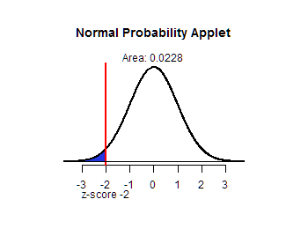
10 | - | reject the null hypothesis
11 | - | There is sufficient to suggest that the proportion of peanuts in the can is less than 20%.
12 | - | (0.023, 0.024) We are 95% confident that the true proportion of the population who die after contracting H1N1 is between 2.3% and 2.4%.
13 | - | (0.547, 0.639) We are 95% confident that the true proportion of the population who die after contracting H5N1 is between 54.7% and 63.9%.
14 | - | The bird flu (H5N1) is by far more deadly! More than half of those who contract the bird flu will die, compared to only 2 to 3% of those who are infected with the swine flu. Fortunately for us, the bird flu is currently onlypassed to humans through contact with infected birds. Epidemiologists are concerned about a global pandemic of this disease, which would almost surely happen if the virus mutates to allow human-to-human transmission.
15 | - | $n=423 people$
16 | - | $n=334 people$
17 | - | 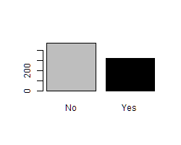
18 | - | $np≥10$  $n(1−p)≥10$  $800(0.43)=344≥10$  $800(1−0.43)=456≥10$  Since both conditions are true, we conclude that $n$ is sufficiently large so that $\overset{^}{p}$ will be approximately distributed.
19 | - | $\overset{^}{p}=0.405$
20 | - | $H_{0}:p=0.43$  $H_{a}:p≠0.43$
21 | - | $z=−1.428$
22 | - | $P−value=0.1532$
23 | - | fail to reject the null hypothesis
24 | - | There is insufficient to suggest that the proportion of adults who received a phishing email in 2012 is different than 43%.

