Lesson 17: Inference for One Proportion
Preparation

Solutions
Please note that the steps show rounded numbers, but that the final answers to the problems are calculated without rounding.
Problem | Part | Solution
1 | - | $\overset{^}{p}=\frac{x}{n}$  x = number of successes  n = number of trials.
2 | - | $\overset{^}{p}±z^{*}\sqrt{\frac{\overset{^}{p}(1−\overset{^}{p})}{n}}$
3 | - | $n\overset{^}{p}≥10$  $n(1−\overset{^}{p})≥10$
4 | - | $n=(\frac{z^{*}}{2m})^{2}$
5 | - | $z=\frac{\overset{^}{p}−p}{\sqrt{\frac{p(1−p)}{n}}}$
6 | - | $np≥10$  $n(1−p)≥10$
7 | A | $\overset{^}{p}=\frac{x}{n}=\frac{684}{1006}=0.6799$
7 | B | $n\overset{^}{p}≥10$ -> $1006*0.6799≥10$ -> $684≥10$  $n(1−\overset{^}{p})≥10$ -> $1006(1−0.6799)≥10$ -> $322≥10$  The requirements are met.
7 | C | $1.96*\sqrt{\frac{\overset{^}{p}(1−\overset{^}{p})}{n}}=1.96*\sqrt{\frac{0.6799(1−0.6799)}{1006}}=0.0288$
7 | D | $\overset{^}{p}±margin of error$ -> $0.6799±0.0288$ -> (0.6511, 0.7087)  We are 95% confident that the true population mean, p, is between 0.6511 and 0.7087.
7 | E | $n=(\frac{z^{*}}{2m})^{2}=(\frac{1.96}{2×0.015})^{2}=4268.4444$ -> $4269$
8 | A | $H_{0}:p=0.6$  $H_{a}:p>0.6$
8 | B | $z=\frac{0.6799−0.6}{\sqrt{\frac{0.6(1−0.6}{1006}}}=5.174$
8 | C | 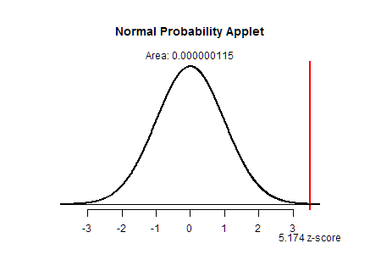  p = 0
8 | D | We reject the null hypothesis
8 | E | We have sufficient evidence to conclude that the true proportion of students that have been in a car accident within the last 5 years is greater than 0.6.

