Lesson 18: Inference for Two Proportions
Homework

Solutions
Please note that the steps show rounded numbers, but that the final answers to the problems are calculated without rounding.
Problem | Part | Solution
1 | - | 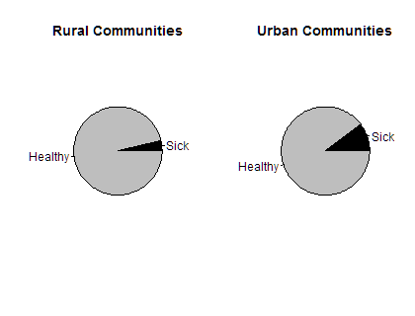
2 | - | $n_{1}×{\overset{^}{p}}_{1}≥10 and n_{1}×(1−{\overset{^}{p}}_{1})≥10$  $261×(0.038)=10≥10 and 261×(1−0.038)=251≥10$  $n_{2}×{\overset{^}{p}}_{2}≥10 and n_{2}×(1−{\overset{^}{p}}_{2})≥10$  $1614×(0.103)=166≥10 and 1614×(1−0.103)=1448≥10$  The requirements are met.
3 | - | ( -0.092 , -0.037 ) We are 95 % confident that the true difference of the proportions of city children with hay fever and rural children with hay fever is between -0.092 and -0.037 .  If you swapped the definition of groups 1 and 2, then you would get the same values with opposite signs: ( 0.037 , 0.092 ). This is also correct.
4 | - | No. This means that it is plausible that the likelihood of a child contracting hay fever is different in the city than in rural areas.
5 | - | $n_{1}×{\overset{^}{p}}_{1}≥10 and n_{1}×(1−{\overset{^}{p}}_{1})≥10$  $200,000×(0.0002)=33≥10 and 200,000×(1−0.0002)=199,967≥10$  $n_{2}×{\overset{^}{p}}_{2}≥10 and n_{2}×(1−{\overset{^}{p}}_{2})≥10$  $200,000×(0.0006)=115≥10 and 200,000×(1−0.0006)=199,885≥10$  The requirements are met.
6 | - | ( -0.00053 , -0.00029 ) We are 95 % confident that the true difference of the proportions of vaccinated children who developed polio and non-vaccinated children who developed polio is -0.00053 and -0.00029 .  If you swapped the definition of groups 1 and 2, then you would get the same values with opposite signs: ( 0.00029 , 0.00053 ). This is also correct.
7 | - | 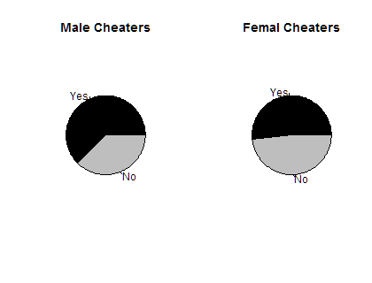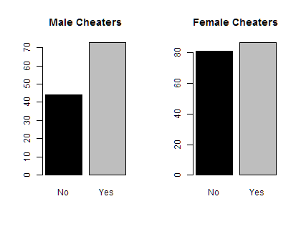
8 | - | $n_{1}×{\overset{^}{p}}_{1}≥10 and n_{1}×(1−{\overset{^}{p}}_{1})≥10$  $117×(0.624)=73≥10 and 117×(1−0.624)=44≥10$  $n_{2}×{\overset{^}{p}}_{2}≥10 and n_{2}×(1−{\overset{^}{p}}_{2})≥10$  $168×(0.518)=87≥10 and 168×(1−0.518)=81≥10$  The requirements are met.
9 | - | $H_{0}:p_{1}=p_{2}$  $H_{a}:p_{1}>p_{2}$
10 | - | $\overset{^}{p_{1}}=0.624$  $\overset{^}{p_{2}}=0.518$
11 | - | $z=1.775$
12 | - | $p-value=0.038$
13 | - | 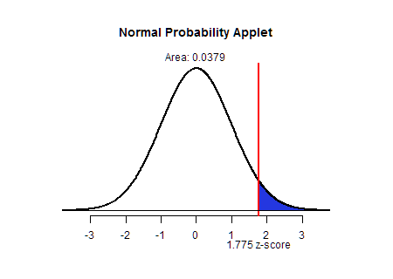
14 | - | reject the null hypothesis
15 | - | There is sufficient evidence to suggest that the proportion of men who cheat in college is greater than the proportion of women who cheat in college.
16 | - | The p-value would double and be equal to 0.076 . This p-value is not significant and we would fail to reject the null hypothesis. With a two sided test we would not have sufficient evidence to conclude that there is a difference between the proportion of women and men who cheat in college.
17 | - | $n_{1}×{\overset{^}{p}}_{1}≥10 and n_{1}×(1−{\overset{^}{p}}_{1})≥10$  $1655×(0.03)=50≥10 and 1655×(1−0.03)=1605≥10$  $n_{2}×{\overset{^}{p}}_{2}≥10 and n_{2}×(1−{\overset{^}{p}}_{2})≥10$  $1652×(0.019)=31≥10 and 1652×(1−0.019)=1621≥10$  The requirements are met.
18 | - | $H_{0}:p_{1}=p_{2}$  $H_{a}:p_{1}≠p_{2}$
19 | - | $\overset{^}{p_{1}}=0.03$  $\overset{^}{p_{2}}=0.019$
20 | - | $z=2.129$
21 | - | $p-value=0.033$
22 | - | 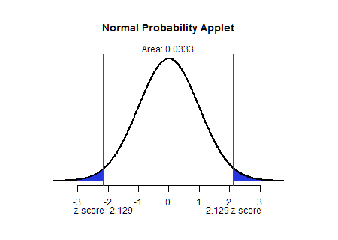
23 | - | reject the null hypothesis
24 | - | There is sufficient evidence to suggestthat the proportion of Clarinex subjects with dry mouth is different than the proportion of placebo subjects with dry mouth.

