Lesson 18: Inference for Two Proportions
Preparation

Solutions
Please note that the steps show rounded numbers, but that the final answers to the problems are calculated without rounding.
Problem | Part | Solution
1 | - | $H_{0}:p_{1}=p_{2}$
2 | - | $z=\frac{({\overset{^}{p}}_{1}−{\overset{^}{p}}_{2})−(p_{1}−p_{2})}{\sqrt{\overset{^}{p}(1−\overset{^}{p})(\frac{1}{n_{1}}+\frac{1}{n_{2}})}}$  ${\overset{^}{p}}_{1}=Sample proportion for group 1$  ${\overset{^}{p}}_{2}=Sample proportion for group 2$  $\overset{^}{p}=Overall sample proportion$  $n_{1}=Sample size for group 1$  $n_{2}=Sample size for group 2$
3 | - | $({\overset{^}{p}}_{1}−{\overset{^}{p}}_{2})±z^{*}\sqrt{\frac{{\overset{^}{p}}_{1}(1−{\overset{^}{p}}_{1})}{n_{1}}+\frac{{\overset{^}{p}}_{2}(1−{\overset{^}{p}}_{2})}{n_{2}}}$  ${\overset{^}{p}}_{1}=Sample proportion for group 1$  ${\overset{^}{p}}_{2}=Sample proportion for group 2$  $n_{1}=Sample size for group 1$  $n_{2}=Sample size for group 2$  $z^{*}=z value for a confidence interval$
4 | A | $296*0.213=63>10$  $251*0.108=27>10$  $296(1−0.213)=233>10$  $251(1−0.108)=224>10$
4 | B | $H_{0}:p_{1}=p_{2}$  $H_{0}:p_{1}≠p_{2}$
4 | C | $z=3.309$
4 | D | $P-value=0.001$
4 | E | 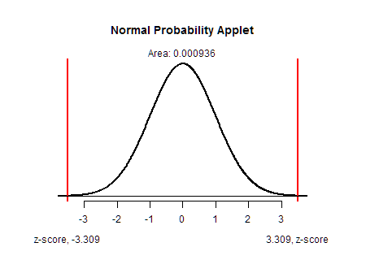  Students should include a sketch of normal distribution curve with both to the left and right of the two z-scores shaded.
4 | F | reject the null hypothesis
4 | G | We have sufficient evidence to say that there is a difference in the proportions of men who use labels and women who use labels.
5 | - | (0.045, 0.165)
6 | - | We are 95% confident that the true difference in the proportions of men being label users and women being label users is between 0.045 and 0.165.

