Lesson 19: Inference for Several Proportions, Goodness-of-Fit, and Independence
Homework

Solutions
Please note that the steps show rounded numbers, but that the final answers to the problems are calculated without rounding.
Problem | Part | Solution
1 | - | The requirements are met because all expected counts are greater than or equal to five
2 | - | 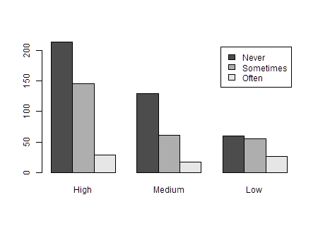
3 | - | $H_{0}:Religiosity and frequency of anger are independent$  $H_{a}:Religiosity and frequency of anger are not independent$
4 | - | $χ^{2}=23.474$  $df=4$
5 | - | $P-value=0.0001$
6 | - | reject the null hypothesis
7 | - | There is sufficient evidence to suggest that religiosity and frequency of anger at something beyond one's control are not independent.
8 | - | The requirements are met because all expected counts are greater than or equal to five
9 | -
10 | - | $H_{0}:Family structure and whether a girl goes to college are independent$  $H_{a}:Family structure and whether a girl goes to college are not independent$
11 | - | $χ^{2}=10.357$  $df=3$
12 | - | $P-value=0.016$
13 | - | reject the null hypothesis
14 | - | There is sufficient evidence to suggest that family structure and whether a girl goes to college are not independent
15 | - | The requirements are met because all expected counts are greater than or equal to five
16 | - | 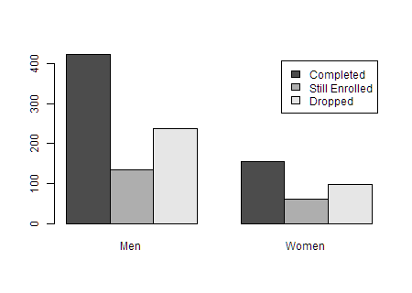
17 | - | $H_{0}:Gender and PhD status are independent$  $H_{a}:Gender and PhD status are not independent.$
18 | - | $χ^{2}=1.932$  $df=2$
19 | - | $P-value=0.381$
20 | - | fail to reject the null hypothesis
21 | - | There is insufficient evidence to conclude that a student's gender and status in a PhD program are not independent.

