L19: Preparation Assignment Worked Solutions 221A
Part I: Concepts
- For a Chi-Square Test for Independence, what are the null and alternative hypotheses?
$$H_{o}: The row variable and the column variable are independent$$
$$H_{a}: The row variable and the column variable are not independent$$
- True/False If the null hypothesis is rejected, then the row variable and column variable are not independent.
True
Part II: Application

- Ambitious Intro to Stats students wanted to conduct a survey among church members and asked them about their party affiliation and whether or not they were in favor of Proposition 8. They would like to see if there is an association between party affiliation and voting preference for Prop 8 with a level of significance of α = 0.05. They conducted a random sample and here is the data summary:
Population | Republican | Democrat
In Favor of Prop 8 | 250 | 120
Against Prop 8 | 50 | 80

  - State the null and alternative hypotheses.

$$H_{o}: Party affiliation and whether they were in favor or against Prop 8 are independent$$
$$H_{a}: Party affiliation and whether they were in favor or against Prop 8 are not independent$$

  - What are the requirements for this test ?

That all of the expected cell counts are greater than 5

  - Are the requirements met?
The expected cell counts are calculated by using the Excel spreadsheet Categorical Data Analysis. Click on the Chi-Square tab at the bottom of the spreadsheet. Then input the data into the correct spots by just copying the data summary table above into the first 4 spots in the Chi-square table. It should appear like the following.

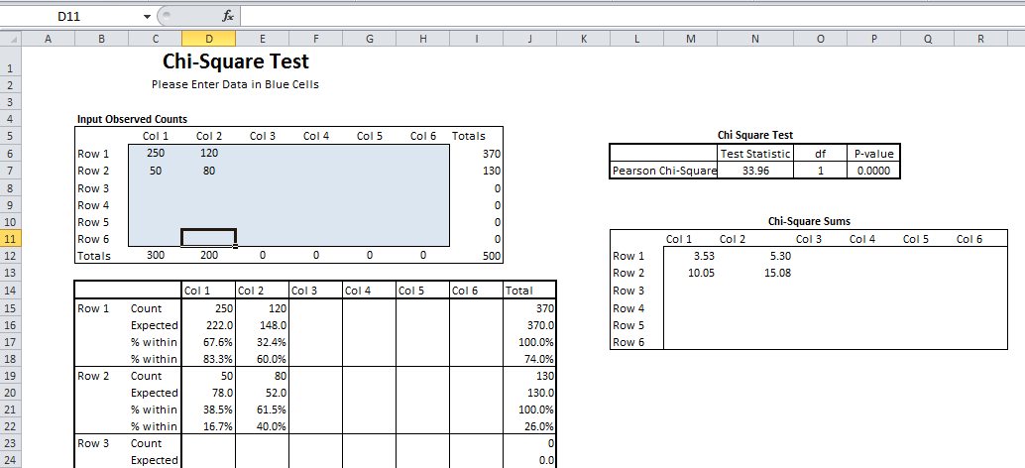
Expected Cell Count Row 1Column 1: 222
Expected Cell Count Row 1 Column 2: 148
Expected Cell Count Row 2 Column 1: 78
Expected Cell Count Row 2 Column 2: 52
Yes they are all greater than 5.

  - Calculate the χ² (Chi-Square) statistic?
This is also found in the Chi-Square Test table above
$χ^{2}$ = 33. 96

  - Determine the Degrees of Freedom for this Test?

df = 1

  - What is the P-value of the χ² statistic?

P-value = 0.0000000056 In Excel it just says 0.000.

  - Do you reject the null hypothesis or fail to reject the null hypothesis?

Reject the null hypothesis

  - State your conclusions based on your p-value and based on a level of significant of α=0.05 (2 pts).
We have sufficient evidence to show that the party affiliation and the voters’ views on Proposition 8 are not independent.

