Lesson 21: Describing Bivariate Data; Scatterplots, Correlation, and Covariance
Homework

Solutions
Please note that the steps show rounded numbers, but that the final answers to the problems are calculated without rounding.
Problem | Part | Solution
1 | - | Linear, moderate negative association.
2 | - | Linear, strong positive association.
3 | - | Linear, moderate positive association.
4 | - | Nonlinear.
5 | - | Linear, moderate positive association.
6 | - | Linear, weak positive association.
7 | - | c. There is a strong negative linear relationship between the variables.
8 | - | 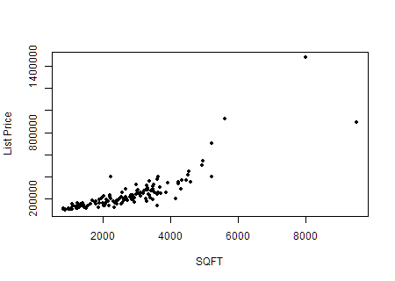
9 | - | Answers will vary. One plausible answer is that it does appear to be linear, with a strong positive association. You may also see slight curve to the data.
10 | - | $r=0.843$
11 | - | If in answer to question 9 you said that the data appear to show a strong positive association that is supported by $r=0.843$ because it is a positive number and it is close to 1.
12 | - | $S_{}xy=178,852,397$
13 | - | 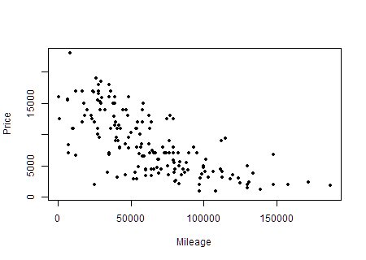
14 | - | Answers will vary. One plausible answer is that it does appear to be linear, with a moderate negative association.
15 | - | $r=−0.687$
16 | - | If in answer to question 14 you said that the data appear to show a moderate negative association that is supported by $r=−0.687$ because it is a negative number and it is right in between 0 and -1.
17 | - | $S_{}xy=−126,615,794$

