Lesson 21: Describing Bivariate Data: Scatterplots, Correlation, and Covariance
Preparation

Solutions
Please note that the steps show rounded numbers, but that the final answers to the problems are calculated without rounding.
Problem | Part | Solution
1 | - | The correlation coefficient is used to measure the direction and strength of the linear association between two variables. The direction can either be positive, negative, or neither, and the strength can be described as weak, moderate, or strong. It is always between -1 and 1 inclusive.
2 | - | Students should have a graph sketched  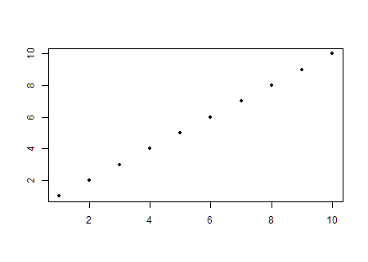
3 | - | $r=0.986$
4 | - | $Covariance1533.734$
5 | - | 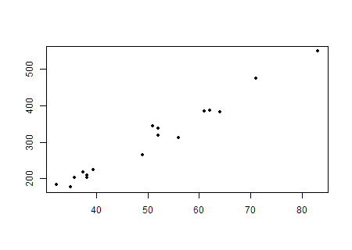
6 | - | There is a strong positive linear relationship between the head length and body length of the Gharial Crocodile.

