L21: Preparation Assignment Worked Solutions 221A
Part I: Concepts
- Describe role of the correlation coefficient. What does it measure? What are its bounds?
The correlation coefficient is used to measure the direction and strength of the linear association between two variables. The direction can either be positive, negative, or neither, and the strength can be described as weak, moderate, or strong. It is always between -1 and 1 inclusive.
- Sketch a graph of 10 $(x,y)$ coordinates on an $x-y$ plane where the data have a strong linear positive correlation.
Students should have a graph sketched here. Here is an example graph. You may either sketch by hand or you can click on Insert – Chart – XY Scatter here in Word to make one similar to the one below.

Part II: Application To answer the following questions, use the Gharial Crocodiles Data.

- The Correlation Coefficient between Head Length and Body Length of the Gharial Crocodiles is:

r = 0.986

To find the correlation coefficient in excel simply open the Gharial Crocodile data and copy and paste each column over into the excel tool Quantitative Inference Procedures under the Linear Regression tab. Paste the head length into the explanatory variable column and the body length into the response variable column. This will give you the following output.

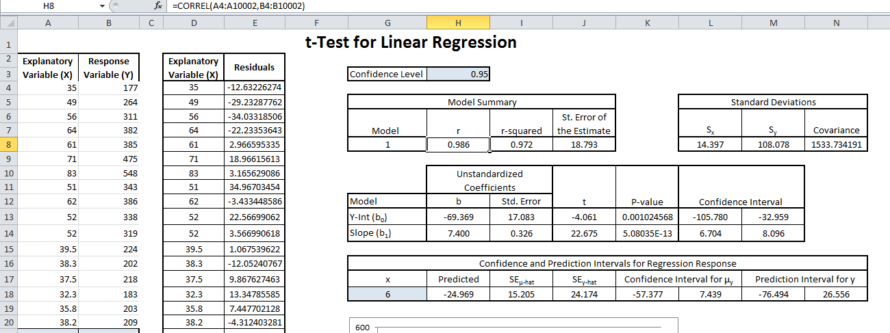
Correlation Coefficient Covariance

- The Covariance of the Head Length and the Body Length of the Gharial Crocodiles is:

Covariance = $r\left(s_{x}\right)\left(s_{y}\right)=$0.986(108.078)14.397 = 1534.215

- Create a scatter plot representing the relationship between Head Length and Body Length of the Gharial Crocodiles. Paste your scatter plot below:

This scatterplot is already made in the same output that we used in the previous problem.
Body Length

Head Length
- Discuss the relationship you see in the scatter plot between the two sets of bivariate data for the Gharial Crocodile.

There is a strong positive linear relationship between the head length and body length of the Gharial Crocodile. We can say this because the data points are going in a positive direction and they are all close around a line.

