Lesson 22: Simple Linear Regression
Homework

Solutions
Please note that the steps show rounded numbers, but that the final answers to the problems are calculated without rounding.
Problem | Part | Solution
1 | - | $Y-Intercept=5.4$
2 | - | $Slope=0.5$
3 | - | $Y=13.4$
4 | - | Height should go on the X-axis, and weight should be on the Y-axis. Height is easier to measure, and can be used to predict weight. We often think of height as influencing weight, but we do not typically think of weight as influencing height.
5 | - | 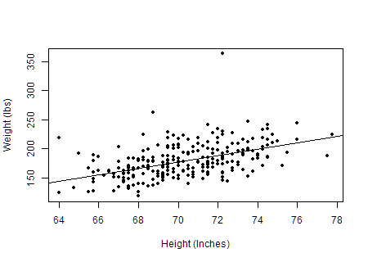
6 | - | $Y=−206.596+5.483X$
7 | - | Slope: If an individual man's height was increased by one inch, we expect that his weight would increase by 5.483 pounds.  Y-Intercept: The Y -intercept is not interpretable. First of all, it is not possible to have a man whose height is zero. Secondly, it does not make sense for the weight to be negative.
8 | - | $Calculator: Y=210.112$  $Software: Y=210.138$
9 | - | 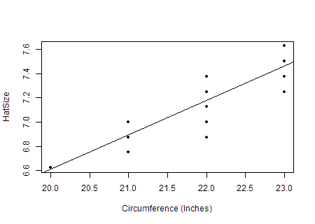
10 | - | $Y=0.99+0.281X$
11 | - | The slope is 0.281, so for every inch increased in head circumference the hat size is increased by 0.281 sizes.  The y-intercept is 0.99, but it is not really interpretable because a person's head circumference can never reach zero.
12 | - | $Calculator: Y=7.734$  $Software: Y=7.74$
13 | - | 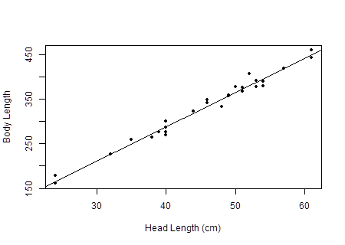
14 | - | $r=0.99$
15 | - | Answers will vary, but it appears to have a linear relationship with a strong positive association.
16 | - | $s_{xy}=714.406$
17 | - | $Y=−18.274+7.66X$
18 | - | The slope is 7.66, so for every centimeter increased in head length the body length is increased by 7.66 centimeters.  The Y -intercept is not interpretable. First of all, it is not possible to have a head length of zero centimeters. Secondly, it does not make sense for a length to be negative.
19 | - | $Calculator: Y=403.026$  $Software: Y=403.032$

