L22: Simple Linear Regression
Preparation

Solutions
Please note that the steps show rounded numbers, but that the final answers to the problems are calculated without rounding.
Problem | Part | Solution
1 | - | Simple Linear Regression allows us to write a linear equation that models the relationship between the independent variable ($X$) and the dependent variable ($Y$).
2 | - | $\overset{^}{Y}=b_{0}+b_{1}X$
3 | - | $Slope=−2.2$
4 | - | $Y-Intercept=1.34$
5 | - | $y=1.34−2.2(5)=−9.66$
6 | - | Head Length
7 | - | Body Length
8 | - | 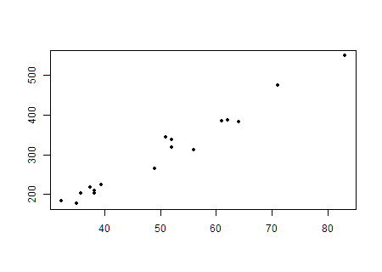  The scatter plot should look like this.
9 | - | $Y-Intercept=−69.369$
10 | - | $Slope=7.4$
11 | - | $\overset{^}{Y}=−69.369+7.4x$
12 | - | 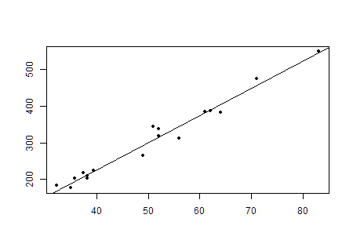
13 | - | $Observed body length=343 cm$
14 | - | If you use the slope equation the result is: $\overset{^}{Y}=308.033 cm$  Answers will vary between 300 and 350.
15 | - | The values are different because the points are not all exactly on the line of best fit. If you look at the graph, visually you can see that the actual point of 51 cm is notably above the line. The line equation is the best estimate but it is not the actual observed measurements.

