L22: Preparation Assignment Worked Solutions 221 B&C
Part I: Concepts
- What is simple linear regression? Explain.
Simple Linear Regression allows us to write a linear equation that models the relationship between the independent variable (X) and the dependent variable (Y).
- What is the formula in the Online Textbook in terms of $\hat{Y}, b_{0}, b_{1}$and$X$which represents the linear equation used to estimate a line relating the variables X and Y (assuming a linear relation exists between these two variables).
$$\hat{Y}= b_{o}+ b_{1}X$$

y-intercept Slope
- For the line: $Y= 1.34-2.2X$, what is the slope?
Slope = -2.2
- For the line: $Y= 1.34-2.2X$, what is the $Y$-intercept?
Y-intercept = 1.34
- Using the prediction line above in #4, predict the value of $Y$ for the input value of $X=5.$
$$y=1.34-2.2\left(5\right)= -9.66$$

Part II: Application To answer the following questions, use the Gharial Crocodiles Data in the Online Textbook under the data link in Course Resources.

- What is the Explanatory Variable? (You will need to review the section in the Online Textbook on the crocodiles to answer this question)
Head Length

- What is the Response Variable? (You will need to review the section in the Online Textbook on the crocodiles to answer this question)
Body Length

- Create a scatter plot representing the relationship between Head Length and Body Length. Paste your plot below.

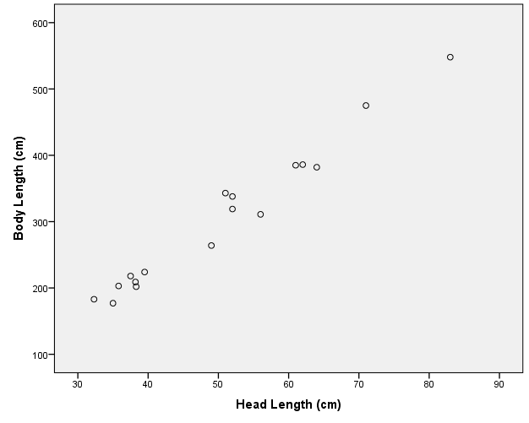

Students scatter plot should look like this. First open the data set Gharial Crocodiles.sav The scatter plot can be made by using SPSS commands, Graphs – Legacy Dialogs – Scatter/Dot. Then click on “Define”. Next move the variable Body Length to the box labeled Y-axis, and the variable Head Length to the box labeled X-axis. Then click on OK.

- Use the software to compute the value of the y-intercept in the regression line.
y-intercept = -69.369
This is found by performing the SPSS commands Analyze – Regression – Linear. Move the variable Head length into the box labeled Independent, and the variable Body length into the box labeled Dependent. Click on OK. This will give you the following output.

Coefficientsª
Model |  | Unstandardized Coefficients |  | Standardized Coefficients | t | Sig.
 |  | B | Std. Error | Beta | t | Sig.
1 | (Constant) | -69.369 | 17.083 |  | -4.061 | .001
1 | Head Length (cm) | 7.400 | .326 | .986 | 22.675 | .000
a. Dependent Variable: Body Length (cm)
Y-intercept Slope
- Use the software to compute the slope of the regression line.

Slope = 7.4

- What is the equation for the regression line computed by the software?

$$\hat{y}= -69.369+7.4x$$
This is found by simply inputting the y-intercept and slope to the Linear regression equation.

- Use the software to draw the regression line on the scatter plot. Insert the picture of scatter plot with graph of the regression line superimposed over the data.

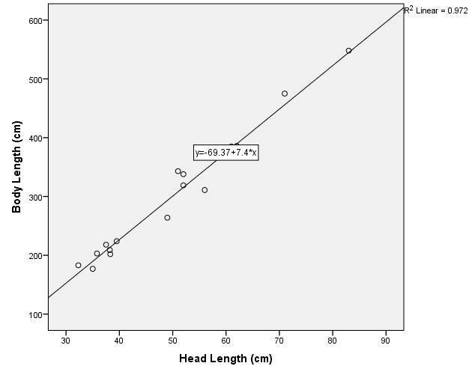

Going back to the scatter plot that you already made in your SPSS output, double click on the scatter plot. This opens the chart editor. Choose the menu option Elements – Fit Line at Total. Then close the Chart Editor.

- For the observed head length of 51 cm, what is the observed body length? (Look in the data file to find this answer.)

Observed body length = 343 cm

This is found by just looking in the Data file Gharial Crocodile.xlsx.

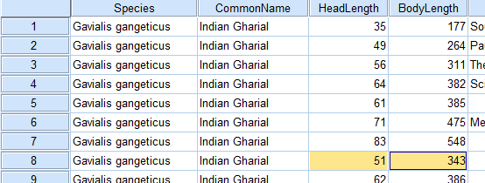

- Use the regression line you obtained in #2 above to predict the body length based on a head length of 51 cm.

$$\hat{y}= -69.369+7.4\left(51\right)=308.031 cm$$
Answers will vary between 300 and 350
Simply plug in 51 for X in your linear regression equation. Or you can also do this on SPSS by following these instructions.
Scroll down to the bottom of your list of data in SPSS. After the last row of data, type the value of X for which you want to predict the value of Y in the cell after the last row in the X column. In this case we would type in 51at the bottom of the head length column. Do not type anything in the body length column. Perform the SPSS commands Analyze – Regression – Linear. Move the Head length into the independent box, and Body length into the Dependent box. Then click on “Save”, and check the box labeled, “Unstandardized predicted values. Click on continue, then okay.
SPSS will have created a new column in the data set called PRE_1. This column will contain the predicted value for each value of X, including the on that you added at the bottom of the data set.
- Why are the values you obtained in #8 and #9 different? Explain.

The values are different because the points are not all exactly on the line of best fit. If you look at the graph, visually you can see that the actual point of 51 cm is notably above the line. The line equation is the best estimate but it is not the actual observed measurements.

