Lesson 23: Inference for Bivariate Data
Homework

Solutions
Please note that the steps show rounded numbers, but that the final answers to the problems are calculated without rounding.
Problem | Part | Solution
1 | - | Estimated linear regression equation:  $$\overset{^}{Y}=b_{0}+b_{1}X$$  True linear regression equation:  $$Y=β_{0}+β_{1}X+ϵ$$
2 | - | See the wiki for a review of this important concept.
3 | A | 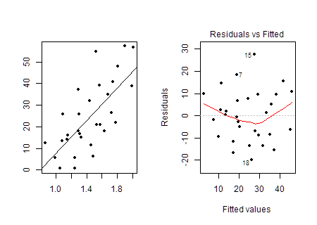  The appropriate graphs to check for a linear relationship are a scatterplot and a residual plot. The scatterplot seems to show a linear relationship and there is no pattern in the residual plot, so we can conclude that there is a linear relationship in the data.
3 | B | 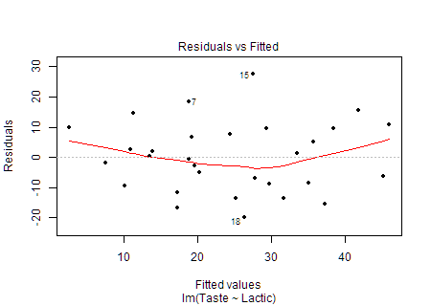  The appropriate graph to check for constant variance is a residual plot. There is no pattern in the residual plot, so we can conclude that there is a constant variance in the data.
3 | C | 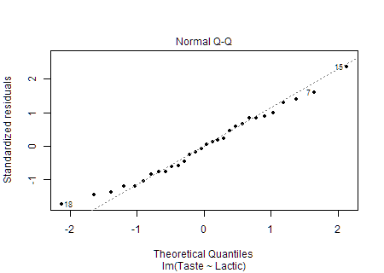  The appropriate graph to check for a normal error term is a Q-Q plot of the residuals. The points in the plot are close to the line, so we can conclude that there is a normal error term in the data.
4 | - | $r=0.704$
5 | - | $\overset{^}{Y}=−29.859+37.72X$
6 | - | $Y=49.73$
7 | - | (22.999, 52.441) We are 95% confident that the slope of the true true linear regression line of Lactic with Taste is between 22.999 and 52.441.
8 | - | $H_{0}:β_{1}=0$  $H_{a}:β_{1}≠0$
9 | - | $t=5.249$
10 | - | $P-value=0.00001405$
11 | - | reject the null hypothesis
12 | - | There is sufficient evidence to suggest that the slope of the true linear regression line does not equal zero. We conclude that there is a linear relationship between the concentration of lactic acid in cheese and the quality of its taste.
13 | A | 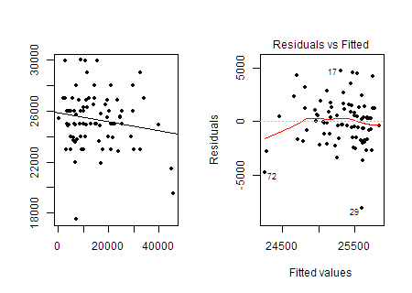  The appropriate graphs to check for a linear relationship are a scatterplot and a residual plot. The scatterplot does not seem to show a significant linear relationship, so we cannot conclude that there is a linear relationship in the data.
13 | B | 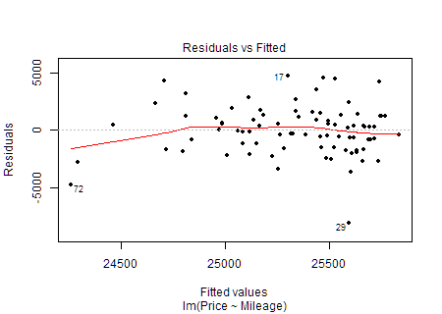  The appropriate graph to check for constant variance is a residual plot. There is no pattern in the residual plot, so we can conclude that there is a constant variance in the data.
13 | C | 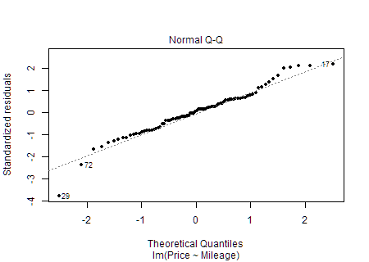  The appropriate graph to check for a normal error term is a Q-Q plot of the residuals. The points in the plot are close to the line, so we can conclude that there is a normal error term in the data.
14 | - | $\overset{^}{Y}=25,838.626+−0.034X$
15 | - | $Y=22,401.192$
16 | - | (-0.073, 0.004) We are 90% confident that the slope of the true true linear regression line of Lactic with Taste is between -0.073 and 0.004.
17 | - | $H_{0}:β_{1}=0$  $H_{a}:β_{1}≠0$
18 | - | $t=−1.476$
19 | - | $P-value=0.144$
20 | - | fail to reject the null hypothesis
21 | - | There is insufficient evidence to suggest that the slope of the true linear regression line does not equal zero. We conclude that there is not a linear relationship between the mileage of a Prius listed for sale and its price.
22 | - | $r=−0.181$
23 | - | $\overset{^}{Y}=62.825+−18.236X$
24 | - | $Y=49.148$
25 | - | (-41.855, 5.383) We are 95% confident that the slope of the true true linear regression line of Lead with BRS is between -41.855 and 5.383.
26 | - | $H_{0}:β_{1}=0$  $H_{a}:β_{1}≠0$
27 | - | $t=−1.54$
28 | - | $P-value=0.128$
29 | - | fail to reject the null hypothesis
30 | - | There is insufficient evidence to suggest that the slope of the true linear regression line does not equal zero. We conclude that there is not a linear relationship between a child's level of lead exposure and his or her behavioral rating.
31 | - | d. The actual Y value was 4.5 units higher than the predicted Y value

