Lesson 23: Inference for Bivariate Data
Preparation

Solutions
Please note that the steps show rounded numbers, but that the final answers to the problems are calculated without rounding.
Problem | Part | Solution
1 | - | 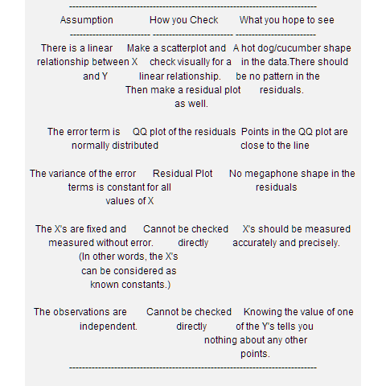
2 | - | $β_{0}$ is the parameter y-intercept for the population  $β_{1}$ is the parameter slope for the population.  $ϵ$ is the error term--a normal random variable.
3 | A | There is a linear relationship between X and Y. - Yes points on the scatter plot are close together and in a 'hotdog' shape.  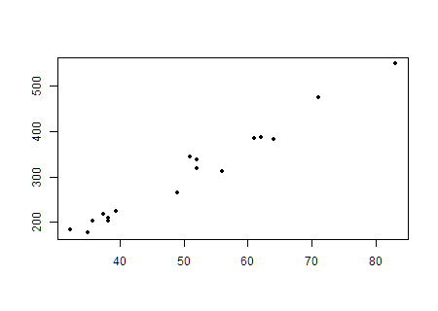
3 | B | The error term $ϵ$ is normally distributed - Yes. Made a QQ plot of the residuals and the points are close to linear.  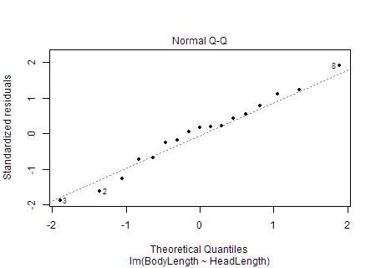
3 | C | The variance of the error terms is constant for all values of X - Yes there is no megaphone shape in the residual scatter plot.  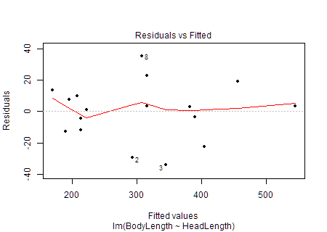
3 | D | X's are fixed and measured without error. (In other words, the X's can be considered as known constants.) We will assume that X's have been measured accurately and precisely.
3 | E | The observations are independent. - We will assume that the Y's are independent.
4 | A | $H_{0}:β_{1}=0$  $H_{a}:β_{2}≠0$
4 | B | $Let alpha=0.05$
4 | C | It is a t-test statistic  $t=22.675$
4 | D | $P-value=0.000000000000508<0.05$  Therefore we reject the null hypothesis.
4 | E | We have sufficient evidence to suggest that there is a linear relationship between the head length and the body length of the Gharial crocodiles.
5 | - | The 95% confidence interval for the true slope of the regression line is (6.704, 8.096)

