L10: Preparation Assignment Worked Solutions 221B&C

Part I: Concepts Use the information in the reading assignment to complete these questions.

- What is a confidence interval?
A confidence interval is an interval of numbers which estimates a population parameter.
- What is the margin of error in a confidence interval when estimating the population mean? This question is not asking for the formula, but rather what length it represents in the confidence interval.
The margin of error is half the width of the confidence interval. It is the distance between the point estimator and one of the bounds of the interval. (If you have a large margin of error, then your confidence interval will also be large. If you have a small margin of error you will also have a small confidence interval.)
- Assuming you know σ, what is the general formula for a confidence interval used to estimate the population mean.
$\overline{x} ±z\frac{σ}{√n}$ or $\overline{x} ±m$
- What are the assumptions for creating a confidence interval for a single mean with sigma known?
      - A simple random sample was drawn from the population.
      - The distribution of the sample mean is normally distributed.
      - Sigma is assumed to be known.
- Open up your Normal Probability Applet and answer the following questions.
  - Go the Normal Probability Applet and type in .90 for the area. Shade the middle area under the curve—leaving the two tails un-shaded. Record the positive z-score below to the nearest hundredth.
Z = 1.645
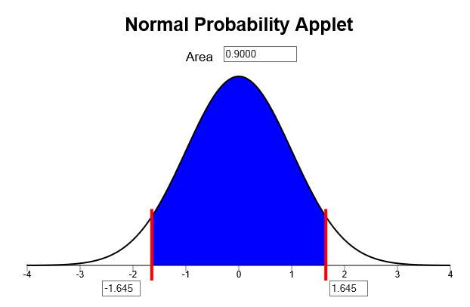
z-score
  - Go the Normal Probability Applet and type in .95 for the area. Shade the middle area under the curve—leaving the two tails un-shaded. Record the positive z-score below to the nearest hundredth.
Z = 1.960
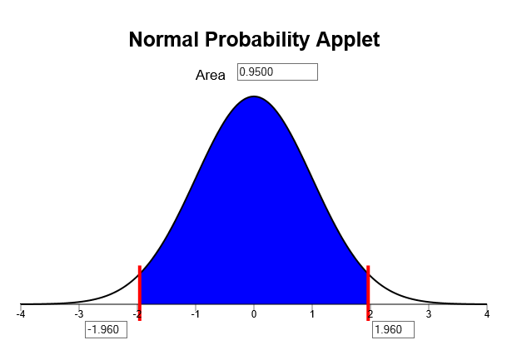
z-score
  - Go the Normal Probability Applet and type in .99 for the area. Shade the middle area under the curve—leaving the two tails un-shaded. Record the positive z-score below to the nearest hundredth.
Z = 2.576
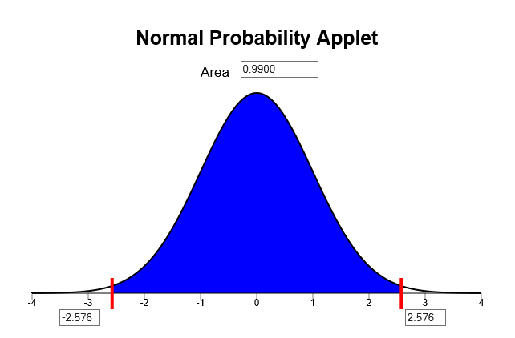 z-score
  - What happens with the z-score as the area in the middle under the normal curve increases?
The z-score also increases.

Part II: Application
- What are the three assumptions that need to be checked before you compute a confidence interval for a mean?
  - A simple random sample was drawn from the population.
  - The distribution of the sample mean is normally distributed.
  - Sigma is assumed to be known.
The Graduate Management Admission Test (GMAT) is used as an admission criterion in many masters of business administration (MBA) programs. A BYU-I professor would like to estimate the population mean from a simple random sample of 50 people’s scores. The sample mean for these 50 students is 541. Assuming a population standard deviation of 32, answer the following questions:
- What is the point estimate for the population mean? 541
We use the sample mean to estimate the population mean. Since the sample mean is 541 this is the point estimate for the population mean.
- Create a 95% confidence interval for the population mean. Show all your work below.
$\overline{x} ±z^{* }\frac{σ}{√n}$ $541 ±1.96\frac{32}{\sqrt{50}}=$ (532.13, 549.87)
- Say that the sample size changes to $n=100.$ Now compute a 95% confidence interval with the same point estimate.
$\overline{x} ±z^{* }\frac{σ}{√n}$ $541 ±1.96\frac{32}{\sqrt{100}}=$ (534.73, 547.27)
- How does the Margin of Error for the 95% confidence interval of sample size 50 compare to the margin of error for the 95% confidence interval of sample size 100?
Notice that the margin of error gets smaller as the sample size grows larger.
- Create a 90% confidence interval for the original 50 students.
$\overline{x} ±z^{* }\frac{σ}{√n}$ $541 ±1.65\frac{32}{\sqrt{50}}=$ (533.56, 548.44)
- How does the Margin of Error for the 95% confidence interval that you computed in question 8 compare to the Margin of Error for the 90% confidence interval that you computed in question 11?
Remember the margin of error is just the second part of the equation or $z^{* }\frac{σ}{√n}$ therefore in comparing the two margins of error, the margin of error for a 95% confidence interval is 8.87 while the margin of error for a 90% confidence interval is 7.47.
The margin of error gets smaller as the level of confidence grows smaller.
- The BYU-I professor would like to repeat the experiment, but he wants to make sure he has enough students in his sample to ensure that his Margin of Error is 5. How many students will need to be in his sample to ensure he has this level of accuracy for a 95% confidence interval?
$n={\left(\frac{zσ}{m}\right)}^{2}={\left(\frac{1.96×32}{5}\right)}^{2}=157.3 → 158$students

