L14: Preparation Assignment Worked Solutions 221B&C
Part I: Concepts
- What are the null and alternative hypotheses for ANOVA?
$$H_{o}:All the means are equal$$
$$H_{a}: One or more of the means differs from the others$$

- For one of the requirements for ANOVA, what is the rule for examining variance of each of the samples?
The rule is if the largest variance is not four times the smallest variance, then we will conclude that the variances are equal.

- What are the differences between the test of hypothesis for ANOVA and the other tests of hypothesis that we have covered to this point of the class (open-ended)?
Answers may vary, but should include that we are now dealing with more than 2 means.
Part II: Application
ANOVA--According to William Butler Yeats, “She is the Gaelic muse, for she gives inspiration to those she persecutes. The Gaelic poets die young, for she is restless, and will not let them remain long on earth.” One study designed to investigate this issue examined the age of death for writers from different cultures and genders. Three categories of writers examined were novelists, poets, and nonfiction writers. The ages at death for female writers in these categories from North America are given in the womenpoet.sav data. You would like to determine if the mean age at death is different from any of the categories of writers. Use α = 0.05 as a level of significance

- Design the Study:
- What is the research question?
Is the mean age at death different from any of the three categories of writers (novelists, poets, and nonfictions writers)?
- State the null and alternative hypothesis.
$$H_{o}: All the means are equal$$
$$H_{a}: One or more of the means differs from the others.$$
- Collect the Data:
- Describe the data collection procedures.
We do not know exactly how the data was collected, we only know that they looked at the ages at death for female writers in North America.
- Describe the Data:
- In a short paragraph use summary statistics to describe the data. After the paragraph insert an appropriate and well labeled graph to illustrate the data.
Students should have a paragraph that includes the following summary statistics. They should also include boxplots or histograms for each sample as their graphs.
 | N | Mean | Std. Deviation
1 | 67 | 71.45 | 13.052
2 | 32 | 63.19 | 17.297
3 | 24 | 76.88 | 14.097
Total | 123 | 70.36 | 15.104
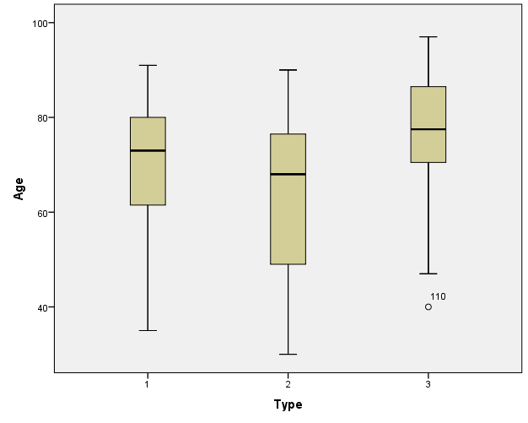
These summary statistics are found by using SPSS. Open the data file (womenpoet.sav) and perform the command Analyze – Compare Means – One-way ANOVA. Move the variable containing data values into the Dependent List box, which in this case is Age. Then move the Type of variable into the Factor box. Click on the options tab. Then make sure the “Descriptives” box is checked. Click on OK. This will give you almost everything you will need for this problem, including the sample size, mean and standard deviation of each group of data.

To make a boxplot like that shown above, perform the SPSS commands Graphs – Legacy Dialogs – Boxplot. Then click on Define. Move the variable Age into the Variable box, and the variable Type into the Category Axis box. Then click on OK.
Inferences:
- What type of hypothesis test is appropriate?
ANOVA test of several means, because we are dealing with more than two means.
- Are the requirements met for this test? Explain.
The data are normally distributed for each group: Note that the requirement is not that the sample means are normal, but that the data themselves are normal; so, the large sample size in groups 1 and 2 do not allow us to assume that the normality assumption is met. This means you need to do a qq-plot for each of the groups. The qq-plots show that the groups are not perfectly normal, but they are probably close enough to proceed with ANOVA.
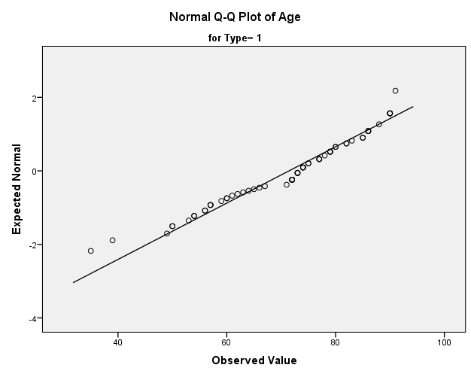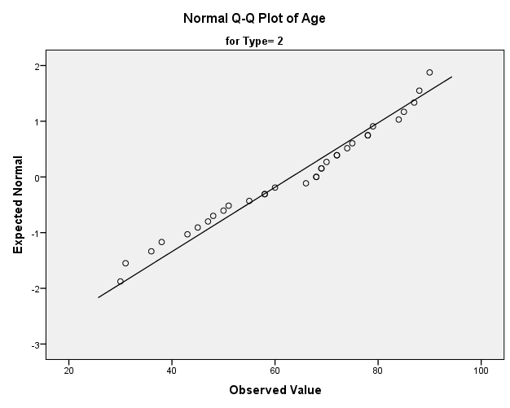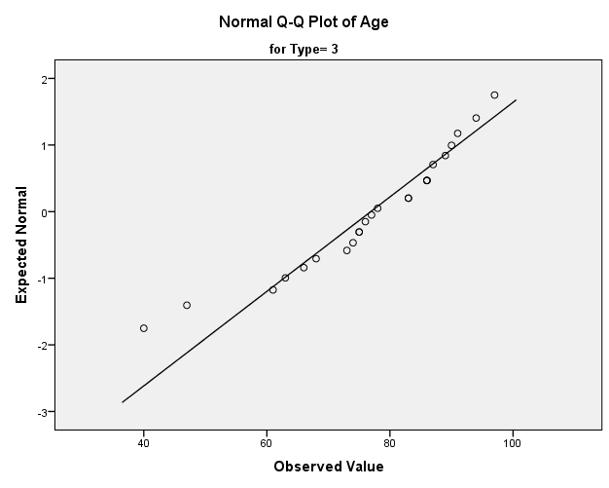

The QQ-plots are made by using SPSS command Analyze – Descriptive Statistics – Explore. Move the variable Age over to the Dependent List box, and Type into the Factor List box. Then click on the “Plots” tab and make sure Normality plots with test box is checked. This will give you all three QQ plots.

The variances for each group are equal: 299.186 is not four times 170.354 so we assume that the variances are equal.
- Compute the test statistic.
F statistic = 6.563

We have already done what is needed to get the test statistic, degrees of freedom, and P-value when we got the descriptive statistics. This is just a different table in the output that looks like the following.

ANOVA
Age
 | Sum of Squares | df | Mean Square | F | Sig.
Between Groups | 2744.193 | 2 | 1372.096 | 6.563 | .002
Within Groups | 25088.067 | 120 | 209.067
Total | 27832.260 | 122

- State the degrees of Freedom.
df = 2, 120
- Compute the P-value and compare it to the alpha level.
P-value = 0.002 < 0.05
- Make a decision. Do you reject the null hypothesis or fail to reject it?
We reject the null hypothesis, because the p-value < alpha.
- Present your conclusions in the form of an English statement.
We have sufficient evidence to say that at least one of the mean ages of death of writers is different from the rest of the mean death ages for the other categories of writers.
- Take Action: With further study we find the poets die earlier than the novelist and non-fiction writers. What significance can you conclude from this?
Answers may vary.
I may conclude that poets are more likely to die earlier than other writers because they are known to be more likely to suffer from mental illnesses. We need to take better care of our poets by providing better mental health care.

